Technical Specification Form

SAP Material Master API

Prepared By: Debidutta Swain (AIRDIT Software Solutions)

**Technical specification content**

1. Business Requirement
2. Development Tools
3. Development Objects

* Table.
* CDS Data Definition.
* CDS Access Control
* SEGW – OData Project.

1. Business API / OData API and Output Screen
2. **Business Requirement:**

Develop an OData GET API for Material Master Details, through which Business user can check Material master data along with the related information like **plant, sales, valuation, storage location** data in External SAP application. In the External SAP application, user can able to see following details in a List view manner. Also, if user want to see the plant/valuation/sales/storage location Details of the Material then they can check through the navigation property provide for individual details.

This following excel provided by Functional consultant based on which I developed the Requirement.



**2.Development Status & Tools**

For development these are the following tool used :

* **Eclipse for ABAP /ADT(ABAP Development Tool)**
* Interface/Basic CDS view:

Created on top of Required Database. Naming convention: ZI_*****

* Composite CDS view:

Created on top of Interface basic view for join/association. Naming convention: ZCO_*****

* Consumption view:

Expose only those field required for Business Requirement. Naming convention: ZC_*****

* **SEGW OData Project**
* Created OData project with “Data Source Reference” Using the consumption CDS view. Here in this CDS association has been done due to which in ODATA project all the association and navigation property generate automatically.
* For Service Registration used Tcode : /N/IWFND/MAINT_SERVICE.
* To Check the final data at Gateway Client used Tcode :/N/IWFND/GW_CLIENT.

NOTE : For CDS development process, I followed the VDM approach.

**3.Development Objects**

* Table:
* **MARA:** General Material Data
* **MARC:** Plant Data for Material
* **MARD(NSDM_V_MARD):** Storage Location Data for Material
* **MBEW:** Material Valuation
* **MVKE:** Sales Data for Material
* **MARM:** Units of Measure for Material
* **MLAN:** Tax Classification for Material
* **CDS Data Definition:**
* **Basic CDS View:**

As I am following the VDM modeling in this development, I had created Basic CDS view on top of Database table and the source of Basic View Should be a Database View or Standard CDS view.

* Table: **MARA:** General Material Data
* CDS view name: ZI_MM_MARA_MaterialData
* //-----------------------------------------------------------------------------------------------------------------------//
* //Created By : AIRDIT--Debidutta Swain(9000RUPESH)
* //Cretaed on : 28-07-2025
* //Description : This BASIC View contain General Material Details.
* //----------------------------------------------------------------------------------------------------------------------//
* @AbapCatalog.sqlViewName: 'ZIMARA'
* @AbapCatalog.compiler.compareFilter: true
* @AbapCatalog.preserveKey: true
* @AccessControl.authorizationCheck: #NOT_REQUIRED
* @EndUserText.label: 'Basic CDS:MARA:General Material Data'
* @VDM.viewType: #BASIC
* **define** **view** ZI_MM_MARA_MaterialData
* **as** **select** **from** mara
* **{**
* **key** matnr **as** MaterialCode**,**
* ersda **as** CreatedOn**,**
* ernam **as** CreatedBy**,**
* laeda **as** LastChangedOn**,**
* aenam **as** ChangedBy**,**
* pstat **as** MaintenanceStatus**,**
* lvorm **as** MaterialForDelation**,**
* mtart **as** MaterialType**,**
* mbrsh **as** IndustrySector**,**
* matkl **as** MaterialGroup**,**
* bismt **as** OldMaterialCode**,**
* meins **as** UOM**,**
* bstme **as** OrderUOM**,**
* groes **as** SizeOrDimensions**,**
* wrkst **as** BasicMaterial**,**
* normt **as** IndustryStandardDescription**,**
* brgew **as** GrossWeight**,**
* ntgew **as** NetWeight**,**
* gewei **as** WeightUnit**,**
* volum **as** Volume**,**
* voleh **as** VolumeUnit**,**
* spart **as** Division**,**
* liqdt **as** ValidTo**,**
* tragr **as** TransactionGroup
* **}**
* Table: **MARC:** Plant Data for Material
* CDS view name: ZI_MM_MARC_MaterialPlantData
* //-----------------------------------------------------------------------------------------------------------------------//
* //Created By : AIRDIT--Debidutta Swain(9000RUPESH)
* //Cretaed on : 28-07-2025
* //Description : This BASIC View contain Plant Data for Material.
* //----------------------------------------------------------------------------------------------------------------------//
* @AbapCatalog.sqlViewName: 'ZIMARC'
* @AbapCatalog.compiler.compareFilter: true
* @AbapCatalog.preserveKey: true
* @AccessControl.authorizationCheck: #NOT_REQUIRED
* @EndUserText.label: 'Basic CDS:MARC:Plant Data for Material'
* @Metadata.ignorePropagatedAnnotations: true
* @VDM.viewType: #BASIC
* **define** **view** ZI_MM_MARC_MaterialPlantData
* **as** **select** **from** marc
* **{**
* **key** matnr **as** MaterialCode**,**
* **key** werks **as** Plant**,**
* xchar **as** BatchMangementIND**,**
* mmsta **as** PSMaterialStatus**,** //Plant-Specific Material Status
* mmstd **as** ValidFromPSMStaus**,** //Date from which the plant-specific material status is valid
* ekgrp **as** PurchasingGroup**,**
* dispr **as** MRPProfile**,**
* dismm **as** MRPType**,**
* dispo **as** MRPController**,**
* plifz **as** PlannedDeliveryTimeDays**,** //Planned Delivery Time in Days
* webaz **as** GEProcessingTimeDays**,** //Goods receipt processing time in days
* perkz **as** PeriodIND**,**
* ausss **as** AssemblyScrap**,**
* disls **as** LotSizeProcedure**,**
* beskz **as** ProcurmentType**,**
* minbe **as** RecorderPoint**,**
* eisbe **as** SaftyStock**,**
* bstmi **as** MinimunLotSize**,**
* bstma **as** MaximumLotSize**,**
* bstfe **as** FixedLotSize**,**
* bstrf **as** RoundingPOQuantity**,** //Rounding value for purchase order quantity
* mabst **as** MaximunStockLevel**,**
* losfx **as** LotSizeIndependentCosts**,**
* sbdkz **as** IndividualAndColl**,** //Dependent requirements ind. for individual and coll. reqmts
* fevor **as** ProductionSupervisor**,**
* bearz **as** ProcessingTime**,**
* ruezt **as** SetupTime**,** //Setup and teardown time
* tranz **as** Interoperation**,**
* basmg **as** BaseQuantity**,**
* dzeit **as** InHouseProductionTime**,**
* maxlz **as** MaxStoragePeriod**,**
* ueeto **as** OverdelyTolerance**,**
* uneto **as** UnderdelyTolerance**,**
* wzeit **as** TotRepLeadTime**,** //Total replenishment lead time (in workdays)
* vzusl **as** SurchargeFactPercent**,** //Surcharge factor for cost in percent
* sproz **as** SampleQuantityPercentage**,** //Sample for quality inspection (in %) (deactivated)
* quazt **as** QuarantinePeriod**,** //Quarantine period (deactivated)
* mpdau **as** MeanInspDuration**,** //Mean inspection duration (deactivated)
* wstgh **as** ActSubstContent**,** //Active substance content (deactivated)
* prfrq **as** InspectionInterval**,**
* nkmpr **as** NextInspection**,**
* umlmc **as** StockInTransfer**,** //Stock in transfer (plant to plant)
* ladgr **as** LoadingGroup**,**
* xchpf **as** BatchManagement**,** //Batch management requirement indicator
* mtvfp **as** AvailabilityCheck**,** //Checking Group for Availability Check
* prctr **as** ProfitCenter**,**
* trame **as** StockIn**,**
* vrmod **as** ConsumptionMode**,**
* verkz **as** VersionIND**,**
* losgr **as** CostingLotSize**,** //Lot Size for Product Costing
* lgpro **as** ProdStorgLocation**,** //Issue Storage Location
* rwpro **as** CoverageProfile**,** //Range of coverage profile
* awsls **as** VarianceKey**,** //Variance Key
* strgr **as** PlanningStrgGroup**,** //Planning Strategy Group
* steuc **as** ControlCode**,** //Control code for consumption taxes in foreign trade
* mcrue **as** MARDHExist**,** //MARDH rec. already exists for per. before last of MARD per.
* lfmon **as** CurrentPeriod**,** //Current period (posting period)
* lfgja **as** YearCurrentPeriod**,** //Fiscal Year of Current Period
* eislo **as** MinSaftyStock**,**
* scm_rrp_type **as** PPPlanningProcd //PP Planning Procedure
* **}**
* Table: **MARD(NSDM_V_MARD):** Storage Location Data for Material
* CDS view name: ZI_MM_MARD_MaterialStorageLoc
* //-----------------------------------------------------------------------------------------------------------------------//
* //Created By : AIRDIT--Debidutta Swain(9000RUPESH)
* //Cretaed on : 28-07-2025
* //Description : This BASIC View contain Storage Location Data for Material.
* //----------------------------------------------------------------------------------------------------------------------//
* @AbapCatalog.sqlViewName: 'ZIMARD'
* @AbapCatalog.compiler.compareFilter: true
* @AbapCatalog.preserveKey: true
* @AccessControl.authorizationCheck: #NOT_REQUIRED
* @EndUserText.label:'Basic CDS:MARD:Storage Location Data for Material'
* @Metadata.ignorePropagatedAnnotations: true
* @VDM.viewType: #BASIC
* **define** **view** ZI_MM_MARD_MaterialStorageLoc
* **as** **select** **from** NSDM_V_MARD
* **{**
* **key** matnr **as** MaterialCode**,**
* **key** werks **as** Plant**,**
* **key** lgort **as** StorageLocation**,**
* pstat **as** MaintenanceStatus**,**
* lvorm **as** DeletionFlagSL**,**
* lfgja **as** YearCurrentPeriod**,**
* lfmon **as** CurrentPeriod**,**
* labst **as** Unrestricted**,**
* umlme **as** StockInTransfer**,** //-------------Stock in transfer (from one storage location to another)
* insme **as** InQualityInsp**,**
* einme **as** RestrictedUseStock**,** //----------Total Stock of All Restricted Batches
* speme **as** Blocked**,**
* retme **as** BlockedStuckReturns**,**
* vmlab **as** UnrestrictedUseStock**,** //--------Valuated unrestricted-use stock in previous period
* vmuml **as** StockInTransfPrevPeriod**,** //-----Stock in Transfer in Previous Period
* vmins **as** InQualityInspPrevPeriod**,** //-----Stock in Quality Inspection in Previous Period
* vmein **as** RestrictUseStockPrevPeriod**,** //--Restricted-Use Stock in Previous Period
* vmspe **as** BlockedStockPrevPeriod**,** //------Blocked stock of previous period
* vmret **as** BlockdStockReturnPrevPeriod //--Blocked Stock Returns in Previous Period
* **}**
* Table: **MBEW:** Material Valuation
* CDS view name: ZI_MM_MARC_MaterialPlantData
* //-----------------------------------------------------------------------------------------------------------------------//
* //Created By : AIRDIT--Debidutta Swain(9000RUPESH)
* //Cretaed on : 28-07-2025
* //Description : This BASIC View contain Material Valuation Details.
* //----------------------------------------------------------------------------------------------------------------------//
* @AbapCatalog.sqlViewName: 'ZIMBEW'
* @AbapCatalog.compiler.compareFilter: true
* @AbapCatalog.preserveKey: true
* @AccessControl.authorizationCheck: #NOT_REQUIRED
* @EndUserText.label: 'Basic CDS:MREW:Material Valuation'
* @Metadata.ignorePropagatedAnnotations: true
* @VDM.viewType: #BASIC
* **define** **view** ZI_MM_MBEW_MaterialValuation
* **as** **select** **from** mbew
* **{**
* **key** matnr **as** MaterialCode**,**
* **key** bwkey **as** ValuationArea**,**
* **key** bwtar **as** ValuationType**,**
* lvorm **as** DeletionFlagVType**,**
* lbkum **as** TotalStock**,** //------------------------Total Valuated Stock
* salk3 **as** TotalValue**,** //------------------------Value of Total Valuated Stock
* vprsv **as** PriceControlIND**,** //------------------Price control indicator
* verpr **as** MovingPrice**,** //-----------------------Moving Average Price/Periodic Unit Price
* stprs **as** StandardPrice**,**
* peinh **as** PriceUnit**,**
* bklas **as** ValuationClass**,**
* salkv **as** ValueOnMovingAvgPrice**,** //-------------Value based on moving average price (only with price ctrl S)
* vmkum **as** TotalStockPP**,** //----------------------Total valuated stock in previous period
* vmsal **as** TotalValuePP**,** //----------------------Value of total valuated stock in previous period
* vmvpr **as** PriceControlPP**,** //--------------------Price Control Indicator in Previous Period
* vmver **as** MovingPricePP**,** //---------------------Moving Average Price/Periodic Unit Price in Previous Period
* vmstp **as** StandardPricePP**,** //-------------------Standard price in the previous period
* vmpei **as** PriceUnitPP**,** //-----------------------Price unit of previous period
* vmbkl **as** ValuationClassPP**,** //------------------Valuation Class in Previous Period
* vmsav **as** ValueOnMovingPricePP**,** //--------------Value based on moving average price (previous period)
* vjkum **as** TotalStockPY**,** //----------------------Total Valuated Stock in Previous Year
* vjsal **as** TotalValuePY**,** //----------------------Value of total valuated stock in previous year
* vjvpr **as** PriceControlPY**,** //--------------------Price Control Indicator in Previous Year
* vjver **as** MovingPricePY**,** //---------------------Moving Average Price/Periodic Unit Price in Previous Year
* vjstp **as** StandardPricePY**,** //-------------------Standard price in previous year
* vjpei **as** PriceUnitPY**,** //-----------------------Price unit of previous year
* vjbkl **as** ValuationClassPY**,** //------------------Valuation Class in Previous Year
* vjsav **as** ValueOnMovingPricePY**,** //--------------Value based on moving average price (previous year)
* lfgja **as** FiscalYearCurrentPeriod**,** //-----------Fiscal Year of Current Period
* zkprs **as** FuturePrice**,** //-----------------------Future Planned Price 1
* zplp1 **as** PlannedPrice1**,**
* zplp2 **as** PlannedPrice2**,**
* zplp3 **as** PlannedPrice3**,**
* zpld1 **as** PPriceDate1**,** //----------------------Date from Which Future Planned Price 1 Is Valid
* zpld2 **as** PPriceDate2**,**
* zpld3 **as** PPriceDate3**,**
* kalkl **as** CureCostEstimate**,** //------------------Standard Cost Estimate for Current Period
* bwva1 **as** ValuationVariantFSCE**,** //--------------Valuation Variant for Future Standard Cost Estimate
* bwva2 **as** ValuationVariantCSCE**,** //--------------Valuation Variant for Current Standard Cost Estimate
* bwva3 **as** ValuationVariantPSCE**,** //--------------Valuation Variant for Previous Standard Cost Estimate
* vers1 **as** CostingVersionFSCE**,** //----------------Costing Version of Future Standard Cost Estimate
* vers2 **as** CostingVersionCSCE**,** //----------------Costing Version of Current Standard Cost Estimate
* vers3 **as** CostingVersionPSCE**,** //----------------Costing Version of Previous Standard Cost Estimate
* hrkft **as** OriginGroup**,** //------------------------Origin Group as Subdivision of Cost Element
* pdatl **as** CurrentFiscalYear**,** //-------------------Fiscal Year of Current Standard Cost Estimate
* pdatv **as** PreviousFiscalYear**,** //--------------------Fiscal Year of Previous Standard Cost Estimate
* ekalr **as** WithQtyStructure**,** //----------Material Is Costed with Quantity Structure
* vplpr **as** PreviousPlannedPrice**,** //-----Previous planned price
* mlmaa **as** MaterialLedgerActive**,** //-------Material Ledger Activated at Material Level
* mlast **as** MatPriceDetermination**,** //------Material Price Determination: Control
* lplpr **as** CurrentPlannedPrice
* **}**
* Table: **MVKE:** Sales Data for Material
* CDS view name: ZI_MM_MVKE_MaterialSalesData
* //-----------------------------------------------------------------------------------------------------------------------//
* //Created By : AIRDIT--Debidutta Swain(9000RUPESH)
* //Cretaed on : 28-07-2025
* //Description : This BASIC View contain Sales Data for Material.
* //----------------------------------------------------------------------------------------------------------------------//
* @AbapCatalog.sqlViewName: 'ZIMVKE'
* @AbapCatalog.compiler.compareFilter: true
* @AbapCatalog.preserveKey: true
* @AccessControl.authorizationCheck: #NOT_REQUIRED
* @EndUserText.label: 'Basic CDS:MVKE:Sales Data for Material'
* @Metadata.ignorePropagatedAnnotations: true
* @vdm.viewType: #BASIC
* **define** **view** ZI_MM_MVKE_MaterialSalesData
* **as** **select** **from** mvke
* **{**
* **key** matnr **as** MaterialCode**,**
* **key** vkorg **as** SalesOrganization**,**
* **key** vtweg **as** DistributionChannel**,**
* lvorm **as** DelationINDAtDCLevel**,** //Ind.: Flag material for deletion at distribution chain level
* kondm **as** MaterialPriceGroup**,**
* ktgrm **as** MaterialAAGroup**,** //Matrial Account Assignment Group
* versg **as** MaterialStatisticsGroup**,**
* sktof **as** CashDeposite**,**
* mtpos **as** ItemCatagoryGroup**,**
* prodh **as** ProductHierarchy
* **}**
* TABLE: **MARM**: Units of Measure for Material
* CDS View name: ZI_MM_MARM_UOMFORMATERIAL
* //--------------------------------------------------------------------------------//
* //Created By : AIRDIT--Debidutta Swain(9000RUPESH)
* //Cretaed on : 29-08-2025
* //Description : This BASIC View contain Units of Measure for Material.
* //------------------------------------------------------------------------------//
* @AbapCatalog.sqlViewName: 'ZIMARM'
* @AbapCatalog.compiler.compareFilter: true
* @AbapCatalog.preserveKey: true
* @AccessControl.authorizationCheck: #NOT_REQUIRED
* @EndUserText.label: 'Basic View:MARM:Units of Measure for Material'
* @Metadata.ignorePropagatedAnnotations: true
* @VDM.viewType: #BASIC
* **define** **view** ZI_MM_MARM_UOMForMaterial
* **as** **select** **from** marm
* **{**
* **key** matnr **as** MaterialCode**,**
* **key** meinh **as** AlternativeUOM**,**
* umrez **as** Counter**,**
* umren **as** Denominator**,**
* @Semantics.quantity.unitOfMeasure: 'VolumeUnit'
* volum **as** Volume**,**
* voleh **as** VolumeUnit**,**
* @Semantics.quantity.unitOfMeasure: 'WeightUnit'
* brgew **as** GrossWeight**,**
* gewei **as** WeightUnit
* **}**
* TABLE: **MLAN:** Tax Classification for Material
* CDS View name: ZI_MM_MLAN_TEXCLASSIFICATION
* //--------------------------------------------------------------//
* //Created By : AIRDIT--Debidutta Swain(9000RUPESH)
* //Cretaed on : 29-07-2025
* //--------------------------------------------------------------//
* @AbapCatalog.sqlViewName: 'ZIMLAN'
* @AbapCatalog.compiler.compareFilter: true
* @AbapCatalog.preserveKey: true
* @AccessControl.authorizationCheck: #NOT_REQUIRED
* @EndUserText.label: 'Basic View:MLAN:Tax Classification for Material'
* @Metadata.ignorePropagatedAnnotations: true
* @VDM.viewType: #BASIC
* **define** **view** ZI_MM_MLAN_TexClassification
* **as** **select** **from** mlan
* **{**
* **key** matnr **as** MaterialCode**,**
* **key** aland **as** DepartureCountryCode**,**
* taxm1 **as** TaxClassifMaterial1**,**
* taxm2 **as** TaxClassifMaterial2**,**
* taxm3 **as** TaxClassifMaterial3**,**
* taxm4 **as** TaxClassifMaterial4**,**
* taxm5 **as** TaxClassifMaterial5**,**
* taxm6 **as** TaxClassifMaterial6**,**
* taxm7 **as** TaxClassifMaterial7**,**
* taxm8 **as** TaxClassifMaterial8**,**
* taxm9 **as** TaxClassifMaterial9**,**
* taxim **as** TaxIndicatorForMaterial
* **}**
* **Composite CDS view**

As I am following the VDM modeling in this development, I had created Composite CDS view on top of Basic View where I will do all the necessary Joins/association needed for the Current Business Requirement.

**List Of Composite CDS view Used:**

* ZCO_MM_MARA_MATERIALDATA
* ZCO_MM_MARC_MATERIALPLANTDATA
* ZCO_MM_MARD_MATERIALSTORAGELOC
* ZCO_MM_MBEW_MATERIALVALUATION
* ZCO_MM_MVKE_MATERIALSALESDATA
* ZCO_MM_MARM_UOMFORMATERIAL
* ZCO_MM_MLAN_TEXCLASSIFICATION
* CDS View : ZCO_MM_MARA_MATERIALDATA
* //-----------------------------------------------------------------------------------------------------------------------//
* //Created By : AIRDIT--Debidutta Swain(9000RUPESH)
* //Cretaed on : 28-07-2025
* //----------------------------------------------------------------------------------------------------------------------//
* @AbapCatalog.sqlViewName: 'ZCOMARA'
* @AbapCatalog.compiler.compareFilter: true
* @AbapCatalog.preserveKey: true
* @AccessControl.authorizationCheck: #NOT_REQUIRED
* @EndUserText.label: 'Composite CDS:MARA:General Material Data'
* @Metadata.ignorePropagatedAnnotations: true
* @VDM.viewType: #COMPOSITE
* **define** **view** ZCO_MM_MARA_MATERIALDATA
* **as** **select** **from** ZI_MM_MARA_MaterialData **as** Mara
* //--> Join For material Description
* **left** **outer** **join** makt **on** Mara**.**MaterialCode **=** makt**.**matnr
* **and** makt**.**spras **=** **$session.system_language**
* //--> join for Material Type Description
* **left** **outer** **join** t134t **on** Mara**.**MaterialType **=** t134t**.**mtart
* **and** t134t**.**spras **=** **$session.system_language**
* //--> Join for industry sector Description
* **left** **outer** **join** t137t **on** Mara**.**IndustrySector **=** t137t**.**mbrsh
* **and** t137t**.**spras **=** **$session.system_language**
* //--> Join for Material Group Description
* **left** **outer** **join** t023t **on** Mara**.**MaterialGroup **=** t023t**.**matkl
* **and** t023t**.**spras **=** **$session.system_language**
* //--> Join for Unit Of Measure Description
* **left** **outer** **join** t006a **as** UOMDESC **on** Mara**.**UOM **=** UOMDESC**.**msehi
* **and** UOMDESC**.**spras **=** **$session.system_language**
* //--> Join for Unit Of Measure Description
* **left** **outer** **join** t006a **as** OUOMDESC **on** Mara**.**OrderUOM **=** OUOMDESC**.**msehi
* **and** OUOMDESC**.**spras **=** **$session.system_language**
* //--> join for Transaction Group Description
* **left** **outer** **join** ttgrt **on** Mara**.**TransactionGroup **=** ttgrt**.**tragr
* **and** ttgrt**.**spras **=** **$session.system_language**
* //--> Joining MARC With MARA to Show plant with material.
* **left** **outer** **join** ZCO_MM_MARC_MATERIALPLANTDATA **as** MARC **on** Mara**.**MaterialCode **=** MARC**.**MaterialCode
* //--> Plant Description
* **left** **outer** **join** t001w **on** MARC**.**Plant **=** t001w**.**werks
* //---------> Making Assiciation For Navigate to Related Details of material.
* **association** **[**0**..*]** **to** ZCO_MM_MARC_MATERIALPLANTDATA **as** _MaterialPlant **on** **$projection.**MaterialCode **=** _MaterialPlant**.**MaterialCode
* **and** **$projection.**Plant **=** _MaterialPlant**.**Plant
* **association** **[**0**..*]** **to** ZCO_MM_MARD_MATERIALSTORAGELOC **as** _MaterialStorageLoc **on** **$projection.**MaterialCode **=** _MaterialStorageLoc**.**MaterialCode
* **and** **$projection.**Plant **=** _MaterialStorageLoc**.**Plant
* **association** **[**0**..*]** **to** ZCO_MM_MVKE_MaterialSalesData **as** _MaterialSales **on** **$projection.**MaterialCode **=** _MaterialSales**.**MaterialCode
* **association** **[**0**..*]** **to** ZCO_MM_MBEW_MATERIALVALUATION **as** _MaterialValuation **on** **$projection.**MaterialCode **=** _MaterialValuation**.**MaterialCode
* **and** **$projection.**Plant **=** _MaterialValuation**.**ValuationArea
* **association** **[**0**..*]** **to** ZCO_MM_MARM_UOMForMaterial **as** _MaterialAlternativeUOM **on** **$projection.**MaterialCode **=** _MaterialAlternativeUOM**.**MaterialCode
* **association** **[**0**..*]** **to** ZCO_MM_MLAN_TEXCLASSIFICATION **as** _MaterialTaxClassification **on** **$projection.**MaterialCode **=** _MaterialTaxClassification**.**MaterialCode
* **{**
* **key** Mara**.**MaterialCode**,**
* **key** MARC**.**Plant**,**
* makt**.**maktx **as** MaterialCodeDescription**,**
* t001w**.**name1 **as** PlantName**,**
* Mara**.**CreatedOn**,**
* Mara**.**CreatedBy**,**
* Mara**.**LastChangedOn**,**
* Mara**.**ChangedBy**,**
* Mara**.**MaintenanceStatus**,**
* Mara**.**MaterialForDelation**,**
* **case** Mara**.**MaterialForDelation
* **when** 'X' **then** 'Yes'
* **else** 'No'
* **end** **as** MaterialForDelationDesc**,**
* Mara**.**MaterialType**,**
* t134t**.**mtbez **as** MaterialTypeDescription**,**
* Mara**.**IndustrySector**,**
* t137t**.**mbbez **as** IndustrySectorDescription**,**
* Mara**.**MaterialGroup**,**
* t023t**.**wgbez60 **as** MaterialGroupDescription**,**
* Mara**.**OldMaterialCode**,**
* Mara**.**UOM**,**
* UOMDESC**.**msehl **as** UOMDescription**,**
* Mara**.**OrderUOM**,**
* OUOMDESC**.**msehl **as** OrderUOMDescription**,**
* Mara**.**SizeOrDimensions**,**
* Mara**.**BasicMaterial**,**
* Mara**.**IndustryStandardDescription**,**
* Mara**.**GrossWeight**,**
* Mara**.**NetWeight**,**
* Mara**.**WeightUnit**,**
* Mara**.**Volume**,**
* Mara**.**VolumeUnit**,**
* Mara**.**Division**,**
* Mara**.**ValidTo**,**
* Mara**.**TransactionGroup**,**
* ttgrt**.**vtext **as** TransactionGroupDescription**,**
* Mara**.**MatlGrpPackMatls**,**
* Mara**.**TotalSelfLife**,**
* Mara**.**MinRemainSelfLife**,**
* Mara**.**SegmantationStructure**,**
* Mara**.**SegmentationStrategy**,**
* Mara**.**SegmentationStatus**,**
* Mara**.**SegmentationStrategyScope**,**
* Mara**.**SegmentationRelevant**,**
* Mara**.**ManufacturePartNo**,**
* Mara**.**Manufacture**,**
* //--> Making Association Public
* _MaterialPlant**,**
* _MaterialStorageLoc**,**
* _MaterialSales**,**
* _MaterialValuation**,**
* _MaterialAlternativeUOM**,**
* _MaterialTaxClassification
* **}**
* **where**
* Mara**.**MaterialForDelation **<>** 'X'
* CDS view: ZCO_MM_MARC_MATERIALPLANTDATA
* //-----------------------------------------------------------------------------------------------------------------------//
* //Created By : AIRDIT--Debidutta Swain(9000RUPESH)
* //Cretaed on : 28-07-2025
* //----------------------------------------------------------------------------------------------------------------------//
* @AbapCatalog.sqlViewName: 'ZCOMARC'
* @AbapCatalog.compiler.compareFilter: true
* @AbapCatalog.preserveKey: true
* @AccessControl.authorizationCheck: #CHECK
* @EndUserText.label: 'Composite CDS:MARC:Material Plant Data'
* @Metadata.ignorePropagatedAnnotations: true
* @VDM.viewType: #COMPOSITE
* **define** **view** ZCO_MM_MARC_MATERIALPLANTDATA
* **as** **select** **from** ZI_MM_MARC_MaterialPlantData **as** MARC
* //--> Fetch the material Unit Of mesure
* **left** **outer** **join** mara **on** MARC**.**MaterialCode **=** mara**.**matnr
* //--> Plant Description
* **left** **outer** **join** t001w **on** MARC**.**Plant **=** t001w**.**werks
* //--> Descriptions of Plant-Specific Material Status
* **left** **outer** **join** t141t **on** MARC**.**PSMaterialStatus **=** t141t**.**mmsta
* **and** t141t**.**spras **=** **$session.system_language**
* //--> Purchasing Groups Description
* **left** **outer** **join** t024 **on** MARC**.**PurchasingGroup **=** t024**.**ekgrp
* //--> MRP Profile Description
* **left** **outer** **join** t401t **on** MARC**.**MRPProfile **=** t401t**.**dispr
* **and** t401t**.**spras **=** **$session.system_language**
* //--> MRP Type Description
* **left** **outer** **join** t438t **on** MARC**.**MRPType **=** t438t**.**dismm
* **and** t438t**.**spras **=** **$session.system_language**
* //--> MRP Controller Description
* **left** **outer** **join** t024d **on** MARC**.**MRPController **=** t024d**.**dispo
* **and** MARC**.**Plant **=** t024d**.**werks
* //--> Procurement Type Description
* **left** **outer** **join** dd07t **as** ProcurmentIND **on** MARC**.**ProcurmentType **=** ProcurmentIND**.**domvalue_l
* **and** ProcurmentIND**.**domname **=** 'BESKZ'
* **and** ProcurmentIND**.**ddlanguage **=** **$session.system_language**
* **{**
* **key** MARC**.**MaterialCode**,**
* **key** MARC**.**Plant**,**
* t001w**.**name1 **as** PlantName**,**
* MARC**.**BatchMangementIND**,**
* **case** MARC**.**BatchMangementIND
* **when** 'X' **then** 'Yes'
* **else** 'No'
* **end** **as** BatchMangementINDText**,**
* MARC**.**PSMaterialStatus**,**
* MARC**.**ValidFromPSMStaus**,**
* MARC**.**PurchasingGroup**,**
* t024**.**eknam **as** PurchasingGroupText**,**
* MARC**.**MRPProfile**,**
* t401t**.**ktext **as** MRPProfileText**,**
* MARC**.**MRPType**,**
* t438t**.**dibez **as** MRPTypeText**,**
* MARC**.**MRPController**,**
* t024d**.**dsnam **as** MRPControllerText**,**
* MARC**.**PlannedDeliveryTimeDays**,**
* MARC**.**GEProcessingTimeDays**,**
* MARC**.**PeriodIND**,**
* MARC**.**AssemblyScrap**,**
* MARC**.**LotSizeProcedure**,**
* MARC**.**ProcurmentType**,**
* ProcurmentIND**.**ddtext **as** ProcurmentTypeText**,**
* mara**.**meins **as** UOM**,**
* @Semantics.quantity.unitOfMeasure: 'UOM'
* MARC**.**RecorderPoint**,**
* @Semantics.quantity.unitOfMeasure: 'UOM'
* MARC**.**SaftyStock**,**
* @Semantics.quantity.unitOfMeasure: 'UOM'
* MARC**.**MinimunLotSize**,**
* @Semantics.quantity.unitOfMeasure: 'UOM'
* MARC**.**MaximumLotSize**,**
* @Semantics.quantity.unitOfMeasure: 'UOM'
* MARC**.**FixedLotSize**,**
* @Semantics.quantity.unitOfMeasure: 'UOM'
* MARC**.**RoundingPOQuantity**,**
* @Semantics.quantity.unitOfMeasure: 'UOM'
* MARC**.**MaximunStockLevel**,**
* MARC**.**LotSizeIndependentCosts**,**
* MARC**.**IndividualAndColl**,**
* MARC**.**ProductionSupervisor**,**
* MARC**.**ProcessingTime**,**
* MARC**.**SetupTime**,**
* MARC**.**Interoperation**,**
* @Semantics.quantity.unitOfMeasure: 'UOM'
* MARC**.**BaseQuantity**,**
* MARC**.**InHouseProductionTime**,**
* MARC**.**MaxStoragePeriod**,**
* MARC**.**OverdelyTolerance**,**
* MARC**.**UnderdelyTolerance**,**
* MARC**.**TotRepLeadTime**,**
* MARC**.**SurchargeFactPercent**,**
* MARC**.**SampleQuantityPercentage**,**
* MARC**.**QuarantinePeriod**,**
* MARC**.**MeanInspDuration**,**
* MARC**.**ActSubstContent**,**
* MARC**.**InspectionInterval**,**
* MARC**.**NextInspection**,**
* @Semantics.quantity.unitOfMeasure: 'UOM'
* MARC**.**StockInTransfer**,**
* MARC**.**LoadingGroup**,**
* MARC**.**BatchManagement**,**
* MARC**.**AvailabilityCheck**,**
* MARC**.**ProfitCenter**,**
* MARC**.**StockIn**,**
* MARC**.**ConsumptionMode**,**
* MARC**.**VersionIND**,**
* @Semantics.quantity.unitOfMeasure: 'UOM'
* MARC**.**CostingLotSize**,**
* MARC**.**ProdStorgLocation**,**
* MARC**.**CoverageProfile**,**
* MARC**.**VarianceKey**,**
* MARC**.**PlanningStrgGroup**,**
* MARC**.**ControlCode**,**
* MARC**.**MARDHExist**,**
* MARC**.**CurrentPeriod**,**
* MARC**.**YearCurrentPeriod**,**
* @Semantics.quantity.unitOfMeasure: 'UOM'
* MARC**.**MinSaftyStock**,**
* MARC**.**PPPlanningProcd
* **}**
* CDS View : ZCO_MM_MARD_MATERIALSTORAGELOC
* //-----------------------------------------------------------------------------------------------------------------------//
* //Created By : AIRDIT--Debidutta Swain(9000RUPESH)
* //Cretaed on : 28-07-2025
* //----------------------------------------------------------------------------------------------------------------------//
* @AbapCatalog.sqlViewName: 'ZCOMARD'
* @AbapCatalog.compiler.compareFilter: true
* @AbapCatalog.preserveKey: true
* @AccessControl.authorizationCheck: #CHECK
* @EndUserText.label: 'Composite CDS:MARD:Storage Location Data for Material'
* @Metadata.ignorePropagatedAnnotations: true
* **define** **view** ZCO_MM_MARD_MATERIALSTORAGELOC
* **as** **select** **from** ZI_MM_MARD_MaterialStorageLoc **as** MARD
* //--> Fetch the Material Uom
* **left** **outer** **join** mara **on** MARD**.**MaterialCode **=** mara**.**matnr
* //--> Material description
* **left** **outer** **join** makt **on** MARD**.**MaterialCode **=** makt**.**matnr
* **and** makt**.**spras **=** **$session.system_language**
* //--> Plant Description
* **left** **outer** **join** t001w **on** MARD**.**Plant **=** t001w**.**werks
* //--> Storage Location Description
* **left** **outer** **join** t001l **on** MARD**.**Plant **=** t001l**.**werks
* **and** MARD**.**StorageLocation **=** t001l**.**lgort
* **{**
* **key** MARD**.**MaterialCode**,**
* **key** MARD**.**Plant**,**
* **key** MARD**.**StorageLocation**,**
* makt**.**maktx **as** MaterialDescription**,**
* t001w**.**name1 **as** PlantName**,**
* t001l**.**lgobe **as** StorageLocDescription**,**
* MARD**.**MaintenanceStatus**,**
* MARD**.**DeletionFlagSL**,**
* MARD**.**YearCurrentPeriod**,**
* mara**.**meins **as** UOM**,**
* MARD**.**CurrentPeriod**,**
* @Semantics.quantity.unitOfMeasure: 'UOM'
* MARD**.**Unrestricted**,**
* @Semantics.quantity.unitOfMeasure: 'UOM'
* MARD**.**StockInTransfer**,**
* @Semantics.quantity.unitOfMeasure: 'UOM'
* MARD**.**InQualityInsp**,**
* @Semantics.quantity.unitOfMeasure: 'UOM'
* MARD**.**RestrictedUseStock**,**
* @Semantics.quantity.unitOfMeasure: 'UOM'
* MARD**.**Blocked**,**
* @Semantics.quantity.unitOfMeasure: 'UOM'
* MARD**.**BlockedStuckReturns**,**
* @Semantics.quantity.unitOfMeasure: 'UOM'
* MARD**.**UnrestrictedUseStock**,**
* @Semantics.quantity.unitOfMeasure: 'UOM'
* MARD**.**StockInTransfPrevPeriod**,**
* @Semantics.quantity.unitOfMeasure: 'UOM'
* MARD**.**InQualityInspPrevPeriod**,**
* @Semantics.quantity.unitOfMeasure: 'UOM'
* MARD**.**RestrictUseStockPrevPeriod**,**
* @Semantics.quantity.unitOfMeasure: 'UOM'
* MARD**.**BlockedStockPrevPeriod**,**
* @Semantics.quantity.unitOfMeasure: 'UOM'
* MARD**.**BlockdStockReturnPrevPeriod
* **}**
* **where**
* MARD**.**DeletionFlagSL **<>** 'X'
* CDS view: ZCO_MM_MBEW_MATERIALVALUATION
* //-----------------------------------------------------------------------------------------------------------------------//
* //Created By : AIRDIT--Debidutta Swain(9000RUPESH)
* //Cretaed on : 28-07-2025
* //----------------------------------------------------------------------------------------------------------------------//
* @AbapCatalog.sqlViewName: 'ZCOMBEW'
* @AbapCatalog.compiler.compareFilter: true
* @AbapCatalog.preserveKey: true
* @AccessControl.authorizationCheck: #CHECK
* @EndUserText.label: 'Composite CDS:MREW:Material Valuation'
* @Metadata.ignorePropagatedAnnotations: true
* @VDM.viewType: #COMPOSITE
* **define** **view** ZCO_MM_MBEW_MATERIALVALUATION
* **as** **select** **from** ZI_MM_MBEW_MaterialValuation **as** mbew
* //--> Material desceiption
* **left** **outer** **join** makt **on** mbew**.**MaterialCode **=** makt**.**matnr
* **and** makt**.**spras **=** **$session.system_language**
* **{**
* **key** mbew**.**MaterialCode**,**
* **key** mbew**.**ValuationArea**,**
* **key** mbew**.**ValuationType**,**
* makt**.**maktx **as** MaterialCodeDesc**,**
* mbew**.**TotalStock**,**
* mbew**.**TotalValue**,**
* mbew**.**PriceControlIND**,**
* mbew**.**MovingPrice**,**
* mbew**.**StandardPrice**,**
* mbew**.**PriceUnit**,**
* mbew**.**ValuationClass**,**
* mbew**.**ValueOnMovingAvgPrice**,**
* mbew**.**TotalStockPP**,**
* mbew**.**TotalValuePP**,**
* mbew**.**PriceControlPP**,**
* mbew**.**MovingPricePP**,**
* mbew**.**StandardPricePP**,**
* mbew**.**PriceUnitPP**,**
* mbew**.**ValuationClassPP**,**
* mbew**.**ValueOnMovingPricePP**,**
* mbew**.**TotalStockPY**,**
* mbew**.**TotalValuePY**,**
* mbew**.**PriceControlPY**,**
* mbew**.**MovingPricePY**,**
* mbew**.**StandardPricePY**,**
* mbew**.**PriceUnitPY**,**
* mbew**.**ValuationClassPY**,**
* mbew**.**ValueOnMovingPricePY**,**
* mbew**.**FiscalYearCurrentPeriod**,**
* mbew**.**FuturePrice**,**
* mbew**.**PlannedPrice1**,**
* mbew**.**PlannedPrice2**,**
* mbew**.**PlannedPrice3**,**
* mbew**.**PPriceDate1**,**
* mbew**.**PPriceDate2**,**
* mbew**.**PPriceDate3**,**
* mbew**.**CureCostEstimate**,**
* mbew**.**ValuationVariantFSCE**,**
* mbew**.**ValuationVariantCSCE**,**
* mbew**.**ValuationVariantPSCE**,**
* mbew**.**CostingVersionFSCE**,**
* mbew**.**CostingVersionCSCE**,**
* mbew**.**CostingVersionPSCE**,**
* mbew**.**OriginGroup**,**
* mbew**.**CurrentFiscalYear**,**
* mbew**.**PreviousFiscalYear**,**
* mbew**.**WithQtyStructure**,**
* mbew**.**PreviousPlannedPrice**,**
* mbew**.**MaterialLedgerActive**,**
* mbew**.**MatPriceDetermination**,**
* mbew**.**CurrentPlannedPrice
* **}**
* **where**
* DeletionFlagVType **<>** 'X'
* CDS view: ZCO_MM_MVKE_MaterialSalesData
* //-----------------------------------------------------------------------------------------------------------------------//
* //Created By : AIRDIT--Debidutta Swain(9000RUPESH)
* //Cretaed on : 28-07-2025
* //----------------------------------------------------------------------------------------------------------------------//
* @AbapCatalog.sqlViewName: 'ZCOMVKE'
* @AbapCatalog.compiler.compareFilter: true
* @AbapCatalog.preserveKey: true
* @AccessControl.authorizationCheck: #NOT_REQUIRED
* @EndUserText.label: 'Composite CDS:MVKE:Sales Data for Material'
* @Metadata.ignorePropagatedAnnotations: true
* @VDM.viewType: #COMPOSITE
* **define** **view** ZCO_MM_MVKE_MaterialSalesData
* **as** **select** **from** ZI_MM_MVKE_MaterialSalesData **as** MVKE
* //--> Material code Desc.
* **left** **outer** **join** makt **on** MVKE**.**MaterialCode **=** makt**.**matnr
* **and** makt**.**spras **=** **$session.system_language**
* //--> Sales Organization Description
* **left** **outer** **join** tvkot **on** MVKE**.**SalesOrganization **=** tvkot**.**vkorg
* **and** tvkot**.**spras **=** **$session.system_language**
* //--> DIstribution Channel Description
* **left** **outer** **join** tvtwt **on** MVKE**.**DistributionChannel **=** tvtwt**.**vtweg
* **and** tvtwt**.**spras **=** **$session.system_language**
* //--> Material Pricing group Description
* **left** **outer** **join** t178t **on** MVKE**.**MaterialPriceGroup **=** t178t**.**kondm
* **and** t178t**.**spras **=** **$session.system_language**
* //--> Material: Account Assignment Group Texts
* **left** **outer** **join** tvkmt **on** MVKE**.**MaterialAAGroup **=** tvkmt**.**ktgrm
* **and** tvkmt**.**spras **=** **$session.system_language**
* //--> Materials: Statistics groups: Texts
* **left** **outer** **join** tvsmt **on** MVKE**.**MaterialStatisticsGroup **=** tvsmt**.**stgma
* **and** tvsmt**.**spras **=** **$session.system_language**
* //--> Materials: Item Category Groups in Mat.Master: Texts
* **left** **outer** **join** tptmt **on** MVKE**.**ItemCatagoryGroup **=** tptmt**.**mtpos
* **and** tptmt**.**spras **=** **$session.system_language**
* //--> Materials: Product hierarchies: Texts
* **left** **outer** **join** t179t **on** MVKE**.**ProductHierarchy **=** t179t**.**prodh
* **and** t179t**.**spras **=** **$session.system_language**
* **{**
* **key** MVKE**.**MaterialCode**,**
* **key** MVKE**.**SalesOrganization**,**
* **key** MVKE**.**DistributionChannel**,**
* makt**.**maktx **as** MaterialCodeText**,**
* tvkot**.**vtext **as** SalesOrganizationText**,**
* tvtwt**.**vtext **as** DistributionChannelText**,**
* MVKE**.**DelationINDAtDCLevel**,**
* MVKE**.**MaterialPriceGroup**,**
* t178t**.**vtext **as** MaterialPriceGroupText**,**
* MVKE**.**MaterialAAGroup**,**
* tvkmt**.**vtext **as** MaterialAAGroupText**,** // Material: Account Assignment Group Texts field
* MVKE**.**MaterialStatisticsGroup**,**
* tvsmt**.**bezei20 **as** MaterialStatisticsGroupText**,**
* MVKE**.**CashDeposite**,**
* MVKE**.**ItemCatagoryGroup**,**
* tptmt**.**bezei **as** ItemCatagoryGroupText**,**
* MVKE**.**ProductHierarchy**,**
* t179t**.**vtext **as** ProductHierarchyText
* **}**
* **where**
* MVKE**.**DelationINDAtDCLevel **<>** 'X'
* CDS view: ZCO_MM_MARM_UOMFORMATERIAL
* //-----------------------------------------------------------------------------------//
* //Created By : AIRDIT--Debidutta Swain(9000RUPESH)
* //Cretaed on : 29-08-2025
* //---------------------------------------------------------------------------------//
* @AbapCatalog.sqlViewName: 'ZCOMARM'
* @AbapCatalog.compiler.compareFilter: true
* @AbapCatalog.preserveKey: true
* @AccessControl.authorizationCheck: #NOT_REQUIRED
* @EndUserText.label: 'Composite View:MARM:UOM for Material'
* @Metadata.ignorePropagatedAnnotations: true
* @VDM.viewType: #COMPOSITE
* **define** **view** ZCO_MM_MARM_UOMForMaterial
* **as** **select** **from** ZI_MM_MARM_UOMForMaterial **as** marm
* **left** **outer** **join** t006a **on** t006a**.**msehi **=** marm**.**AlternativeUOM
* **and** t006a**.**spras **=** **$session.system_language**
* **{**
* **key** marm**.**MaterialCode**,**
* **key** marm**.**AlternativeUOM**,**
* t006a**.**msehl **as** AlternativeUOMText**,**
* marm**.**Counter**,**
* marm**.**Denominator**,**
* marm**.**Volume**,**
* marm**.**VolumeUnit**,**
* marm**.**GrossWeight**,**
* marm**.**WeightUnit
* **}**
* //-----------------------------------------------------------------------------------------------------------------------//
* //Created By : AIRDIT--Debidutta Swain(9000RUPESH)
* //Cretaed on : 28-07-2025
* //----------------------------------------------------------------------------------------------------------------------//
* @AbapCatalog.sqlViewName: 'ZCOMVKE'
* @AbapCatalog.compiler.compareFilter: true
* @AbapCatalog.preserveKey: true
* @AccessControl.authorizationCheck: #NOT_REQUIRED
* @EndUserText.label: 'Composite CDS:MVKE:Sales Data for Material'
* @Metadata.ignorePropagatedAnnotations: true
* @VDM.viewType: #COMPOSITE
* **define** **view** ZCO_MM_MVKE_MaterialSalesData
* **as** **select** **from** ZI_MM_MVKE_MaterialSalesData **as** MVKE
* //--> Material code Desc.
* **left** **outer** **join** makt **on** MVKE**.**MaterialCode **=** makt**.**matnr
* **and** makt**.**spras **=** **$session.system_language**
* //--> Sales Organization Description
* **left** **outer** **join** tvkot **on** MVKE**.**SalesOrganization **=** tvkot**.**vkorg
* **and** tvkot**.**spras **=** **$session.system_language**
* //--> DIstribution Channel Description
* **left** **outer** **join** tvtwt **on** MVKE**.**DistributionChannel **=** tvtwt**.**vtweg
* **and** tvtwt**.**spras **=** **$session.system_language**
* //--> Material Pricing group Description
* **left** **outer** **join** t178t **on** MVKE**.**MaterialPriceGroup **=** t178t**.**kondm
* **and** t178t**.**spras **=** **$session.system_language**
* //--> Material: Account Assignment Group Texts
* **left** **outer** **join** tvkmt **on** MVKE**.**MaterialAAGroup **=** tvkmt**.**ktgrm
* **and** tvkmt**.**spras **=** **$session.system_language**
* //--> Materials: Statistics groups: Texts
* **left** **outer** **join** tvsmt **on** MVKE**.**MaterialStatisticsGroup **=** tvsmt**.**stgma
* **and** tvsmt**.**spras **=** **$session.system_language**
* //--> Materials: Item Category Groups in Mat.Master: Texts
* **left** **outer** **join** tptmt **on** MVKE**.**ItemCatagoryGroup **=** tptmt**.**mtpos
* **and** tptmt**.**spras **=** **$session.system_language**
* //--> Materials: Product hierarchies: Texts
* **left** **outer** **join** t179t **on** MVKE**.**ProductHierarchy **=** t179t**.**prodh
* **and** t179t**.**spras **=** **$session.system_language**
* **{**
* **key** MVKE**.**MaterialCode**,**
* **key** MVKE**.**SalesOrganization**,**
* **key** MVKE**.**DistributionChannel**,**
* makt**.**maktx **as** MaterialCodeText**,**
* tvkot**.**vtext **as** SalesOrganizationText**,**
* tvtwt**.**vtext **as** DistributionChannelText**,**
* MVKE**.**DelationINDAtDCLevel**,**
* MVKE**.**MaterialPriceGroup**,**
* t178t**.**vtext **as** MaterialPriceGroupText**,**
* MVKE**.**MaterialAAGroup**,**
* tvkmt**.**vtext **as** MaterialAAGroupText**,** // Material: Account Assignment Group Texts field
* MVKE**.**MaterialStatisticsGroup**,**
* tvsmt**.**bezei20 **as** MaterialStatisticsGroupText**,**
* MVKE**.**CashDeposite**,**
* MVKE**.**ItemCatagoryGroup**,**
* tptmt**.**bezei **as** ItemCatagoryGroupText**,**
* MVKE**.**ProductHierarchy**,**
* t179t**.**vtext **as** ProductHierarchyText
* **}**
* **where**
* MVKE**.**DelationINDAtDCLevel **<>** 'X'
* CDS View : ZCO_MM_MLAN_TEXCLASSIFICATION
* //--------------------------------------------------------------//
* //Created By : AIRDIT--Debidutta Swain(9000RUPESH)
* //Cretaed on : 29-07-2025
* //--------------------------------------------------------------//
* @AbapCatalog.sqlViewName: 'ZCOMLAN'
* @AbapCatalog.compiler.compareFilter: true
* @AbapCatalog.preserveKey: true
* @AccessControl.authorizationCheck: #NOT_REQUIRED
* @EndUserText.label: 'Coposite View:MLAN:Tax Classification for Material'
* @Metadata.ignorePropagatedAnnotations: true
* @VDM.viewType: #COMPOSITE
* **define** **view** ZCO_MM_MLAN_TEXCLASSIFICATION
* **as** **select** **from** ZI_MM_MLAN_TexClassification **as** MLAN
* **left** **outer** **join** t005t **on** t005t**.**land1 **=** MLAN**.**DepartureCountryCode
* **and** t005t**.**spras **=** **$session.system_language**
* **{**
* **key** MLAN**.**MaterialCode**,**
* **key** MLAN**.**DepartureCountryCode**,**
* t005t**.**landx50 **as** DepartureCountryCodeText**,**
* MLAN**.**TaxClassifMaterial1**,**
* MLAN**.**TaxClassifMaterial2**,**
* MLAN**.**TaxClassifMaterial3**,**
* MLAN**.**TaxClassifMaterial4**,**
* MLAN**.**TaxClassifMaterial5**,**
* MLAN**.**TaxClassifMaterial6**,**
* MLAN**.**TaxClassifMaterial7**,**
* MLAN**.**TaxClassifMaterial8**,**
* MLAN**.**TaxClassifMaterial9**,**
* MLAN**.**TaxIndicatorForMaterial
* **}**
* **Consumption CDS view**

As I am following the VDM modeling in this development, I had created Consumption CDS view on top of Composite CDS View where I had added all the field which are need to Expose as per the Business Requirement.

* CDS View name: ZC_MM_MATERIALDETAILS
* //-----------------------------------------------------------------------------------------------------------------------//
* //Created By : AIRDIT--Debidutta Swain(9000RUPESH)
* //Cretaed on : 29-07-2025
* //----------------------------------------------------------------------------------------------------------------------//
* @AbapCatalog.sqlViewName: 'ZCMATERIAL'
* @AbapCatalog.compiler.compareFilter: true
* @AbapCatalog.preserveKey: true
* @AccessControl.authorizationCheck: #CHECK
* @EndUserText.label: 'Consuption View:Material Master Details'
* @Metadata.ignorePropagatedAnnotations: true
* @VDM.viewType: #CONSUMPTION
* **define** **view** ZC_MM_MaterialDetails
* **as** **select** **from** ZCO_MM_MARA_MATERIALDATA
* **{**
* **key** MaterialCode**,**
* **key** Plant**,**
* MaterialCodeDescription**,**
* PlantName**,**
* CreatedOn**,**
* CreatedBy**,**
* LastChangedOn**,**
* ChangedBy**,**
* MaintenanceStatus**,**
* MaterialForDelation**,**
* MaterialForDelationDesc**,**
* MaterialType**,**
* MaterialTypeDescription**,**
* IndustrySector**,**
* IndustrySectorDescription**,**
* MaterialGroup**,**
* MaterialGroupDescription**,**
* OldMaterialCode**,**
* UOM**,**
* UOMDescription**,**
* OrderUOM**,**
* OrderUOMDescription**,**
* SizeOrDimensions**,**
* BasicMaterial**,**
* IndustryStandardDescription**,**
* GrossWeight**,**
* NetWeight**,**
* WeightUnit**,**
* Volume**,**
* VolumeUnit**,**
* Division**,**
* ValidTo**,**
* TransactionGroup**,**
* TransactionGroupDescription**,**
* MatlGrpPackMatls**,**
* TotalSelfLife**,**
* MinRemainSelfLife**,**
* SegmantationStructure**,**
* SegmentationStrategy**,**
* SegmentationStatus**,**
* SegmentationStrategyScope**,**
* SegmentationRelevant**,**
* ManufacturePartNo**,**
* Manufacture**,**
* /*----------------------------------- Associations -----------------------------------*/
* _MaterialPlant**,**
* _MaterialSales**,**
* _MaterialStorageLoc**,**
* _MaterialValuation**,**
* _MaterialAlternativeUOM**,**
* _MaterialTaxClassification
* **}**

Note : Here association will behave same as ODATA association and when we will do reference to data source using the Consumption CDS view, then SADL framework will generate all the association and navigation properties based on the CDS modeling automatically.

* **CDS Access Control:**
* CDS View name where used: ZC_MM_MATERIALDETAILS
* CDS Access Control Name: ZDCL_MM_MATERIALMASTER
* @EndUserText.label: 'DCL for Material Master detail based on Plant'
* @MappingRole: true
* **define** **role** ZDCL_MM_MATERIALMASTER **{**
* **grant**
* **select**
* **on**
* ZC_MM_MaterialDetails
* **where**
* **(**Plant**)** **=** **aspect** **pfcg_auth(**ZPLANTS**,**WERKS**);**
* **}**
* CDS View name where used: ZCO_MM_MARC_MATERIALPLANTDATA
* CDS Access Control Name: ZDCL_MM_MARC_PLANTDETAIL
* @EndUserText.label: 'DCL for Authorized Plant Detail Access'
* @MappingRole: true
* **define** **role** ZDCL_MM_MARC_PLANTDETAIL **{**
* **grant**
* **select**
* **on**
* ZCO_MM_MARC_MATERIALPLANTDATA
* **where**
* **(**Plant**)** **=** **aspect** **pfcg_auth(**ZPLANTS**,**WERKS**);**
* **}**
* CDS View name where used: ZCO_MM_MARD_MATERIALSTORAGELOC
* CDS Access Control Name: ZDCL_MM_STORAGELOCATION
* @EndUserText.label: 'DCL for Material Storage Location detail based on Plant'
* @MappingRole: true
* **define** **role** ZDCL_MM_STORAGELOCATION **{**
* **grant**
* **select**
* **on**
* ZCO_MM_MARD_MATERIALSTORAGELOC
* **where**
* **(**Plant**)** **=** **aspect** **pfcg_auth(**ZPLANTS**,**WERKS**);**
* **}**
* CDS View name where used: ZCO_MM_MBEW_MATERIALVALUATION
* CDS Access Control Name: ZDCL_MM_MATERIALVALUATION
* @EndUserText.label: 'DCL for Material Valuation detail based on Plant'
* @MappingRole: true
* **define** **role** ZDCL_MM_MATERIALVALUATION **{**
* **grant**
* **select**
* **on**
* ZCO_MM_MBEW_MATERIALVALUATION
* **where**
* **(**ValuationArea**)** **=** **aspect** **pfcg_auth(**ZPLANTS**,**WERKS**);**
* **}**
* **SEGW – OData Project**

**Project Name:** **ZGW_MM_MATERIAL_MASTER_DETAIL**

**Service Name:** **ZGW_MM_MATERIAL_MASTER_DETAIL_SRV**

**Entity Type:**

* ZC_MM_MaterialDetailsType
* ZCO_MM_MARC_MATERIALPLANTDATAType
* ZCO_MM_MARD_MATERIALSTORAGELOCType
* ZCO_MM_MBEW_MATERIALVALUATIONType
* ZCO_MM_MVKE_MaterialSalesDataType
* ZCO_MM_MARM_UOMForMaterialType
* ZCO_MM_MLAN_TEXCLASSIFICATIONType

**Entity set:**

* ZC_MM_MaterialDetails
* ZCO_MM_MARC_MATERIALPLANTDATA
* ZCO_MM_MARD_MATERIALSTORAGELOC
* ZCO_MM_MBEW_MATERIALVALUATION
* ZCO_MM_MVKE_MaterialSalesData
* ZCO_MM_MARM_UOMForMaterial
* ZCO_MM_MLAN_TEXCLASSIFICATION

**Navigation Properties:**

* to_MaterialPlant : Fetch the Related Plant details of material.
* to_MaterialSales: Fetch the related sales details of material.
* to_MaterialStorageLoc: Fetch the related Storage location details of Material.
* to_MaterialValuation: Fetch the related Material valuation details of material.
* to_MaterialAlternativeUOM: Fetch the Alternative UOM of Material .
* 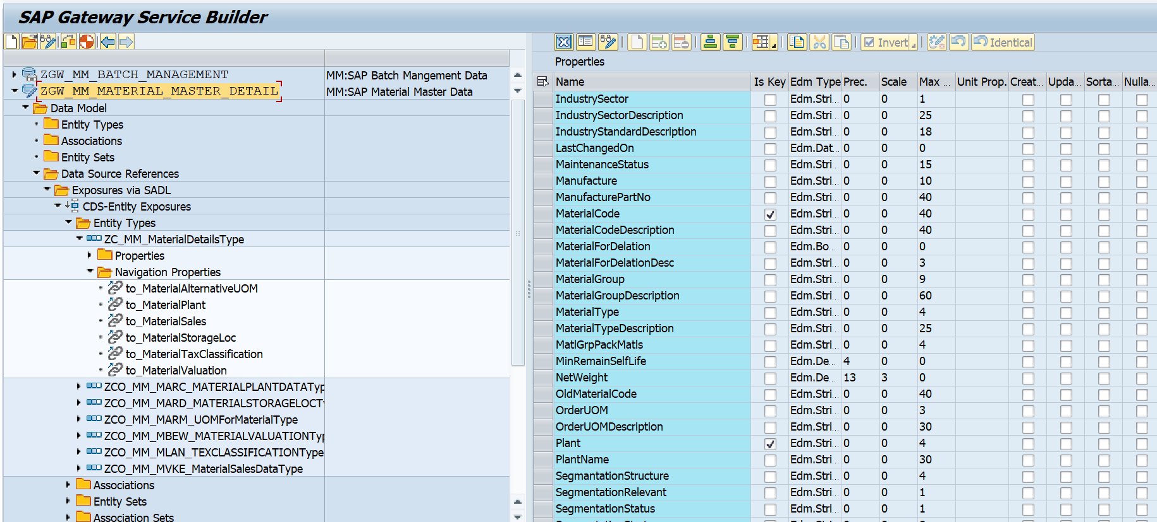to_MaterialTaxClassification: Fetch the Material Tex Classification Data

**Runtime Artifacts:**

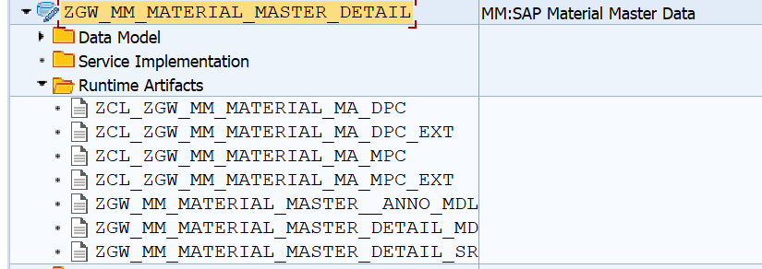

**4.Business API / OData API and Output Screen:**

**Case 1: Checking Material details of a specific “Crated on date” or “Changed On date”**

* ***ERSDA (Created On): 26.05.2025***

SAP GUI Testing  
API For Check the material data on the above date Criteria: /sap/opu/odata/sap/ZGW_MM_MATERIAL_MASTER_DETAIL_SRV/ZC_MM_MaterialDetails?$filter=CreatedOn eq datetime'2025-05-26T00:00:00'  
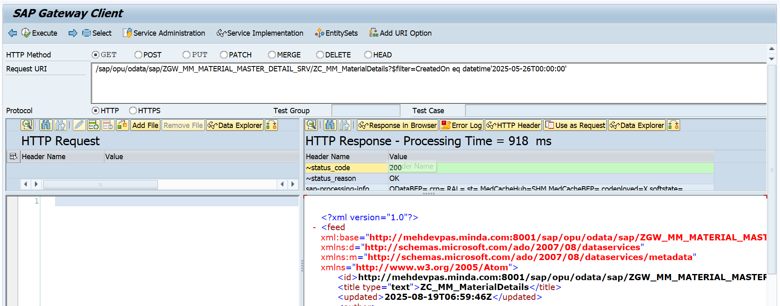

API for Check Number of Records for the above filter criteria:  
/sap/opu/odata/sap/ZGW_MM_MATERIAL_MASTER_DETAIL_SRV/ZC_MM_MaterialDetails/$count?$filter=CreatedOn eq datetime'2025-06-07T00:00:00'

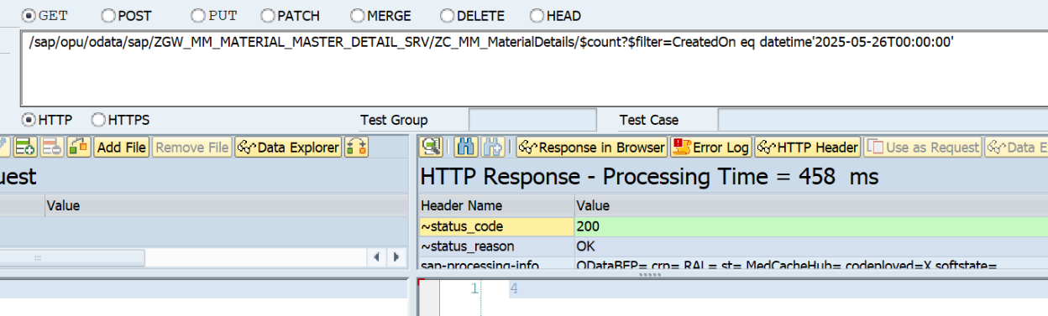

Postman API Testing

http://11.1.3.57:8001/sap/opu/odata/sap/ZGW_MM_MATERIAL_MASTER_DETAIL_SRV/ZC_MM_MaterialDetails?$filter=CreatedOn eq datetime'2025-05-26T00:00:00'

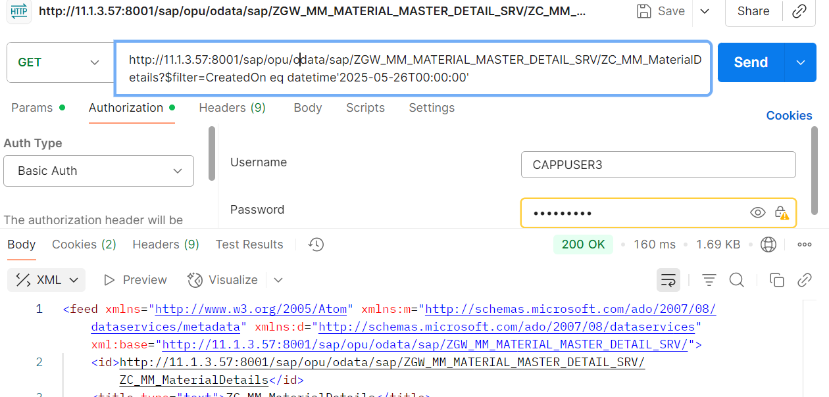

* ***LADAT (Last Changed ON):04.08.2025***

API For Check the material data on the above date Criteria: /sap/opu/odata/sap/ZGW_MM_MATERIAL_MASTER_DETAIL_SRV/ZC_MM_MaterialDetails?$filter=LastChangedOn eq datetime'2025-03-22T00:00:00'

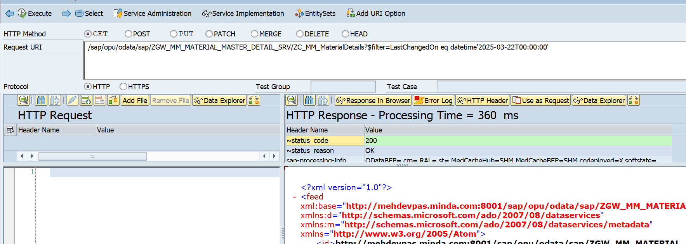

API for Check Number of Records for the above filter criteria:

/sap/opu/odata/sap/ZGW_MM_MATERIAL_MASTER_DETAIL_SRV/ZC_MM_MaterialDetails/$count?$filter=LastChangedOn eq datetime'2025-03-22T00:00:00'

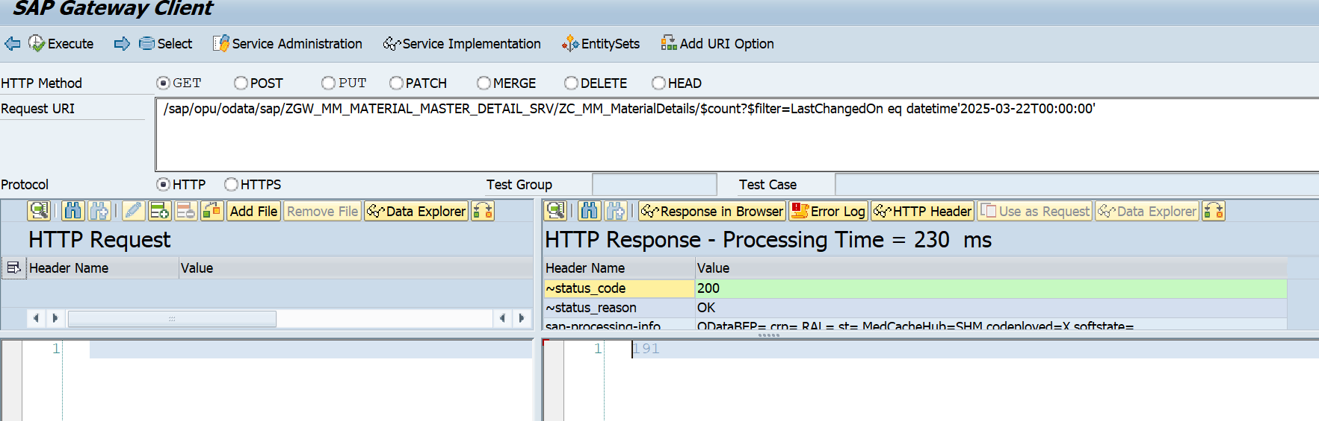

Postman Level check:

http://mehdevpas.minda.com:8001/sap/opu/odata/sap/ZGW_MM_MATERIAL_MASTER_DETAIL_SRV/ZC_MM_MaterialDetails?$filter=LastChangedOn eq datetime'2025-03-22T00:00:00'

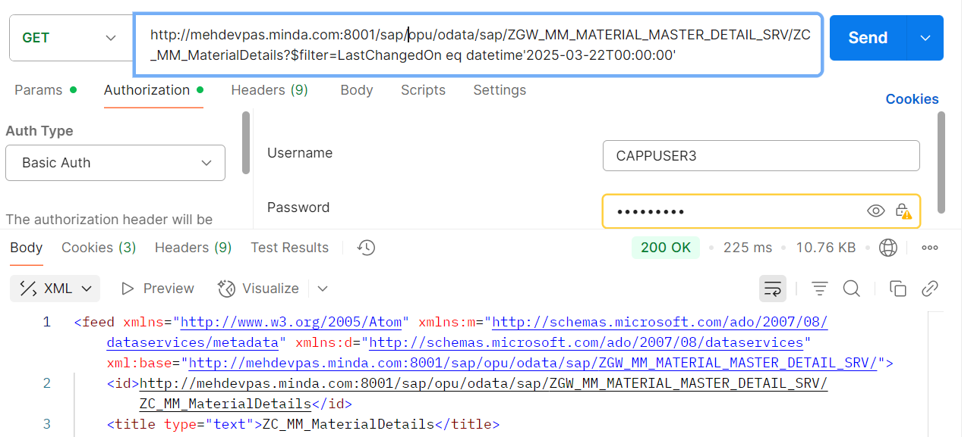

**Case 2: If user pass the Input value as Range Manner.**

* ***ERSDA (Created On): 08-08-2024 to 19-08-2025***

SAP GUI Testing  
API For Check the material data on the above date Criteria:

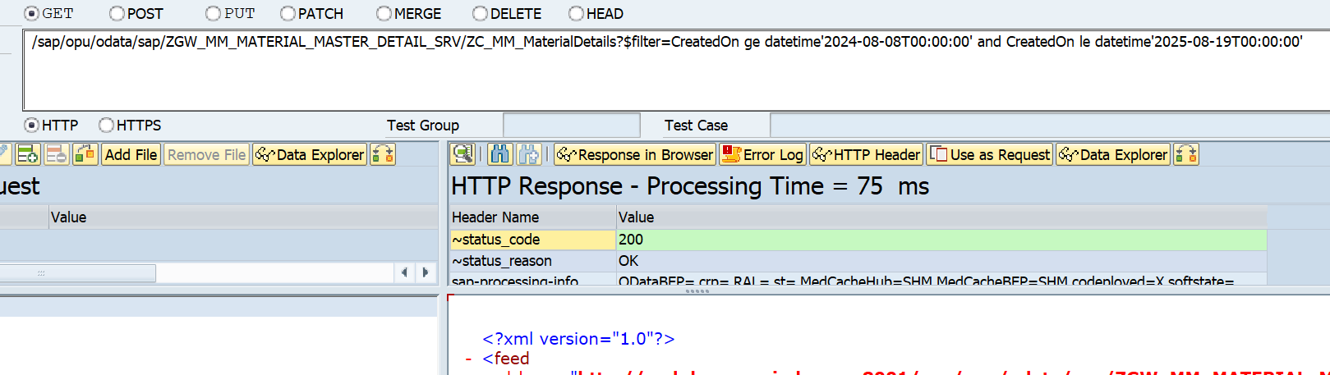/sap/opu/odata/sap/ZGW_MM_MATERIAL_MASTER_DETAIL_SRV/ZC_MM_MaterialDetails?$filter=CreatedOn ge datetime'2024-08-08T00:00:00' and CreatedOn le datetime'2025-08-19T00:00:00'

API for Check the Number of record for Check .

/sap/opu/odata/sap/ZGW_MM_MATERIAL_MASTER_DETAIL_SRV/ZC_MM_MaterialDetails/$count?$filter=CreatedOn ge datetime'2024-08-08T00:00:00' and CreatedOn le datetime'2025-08-19T00:00:00'

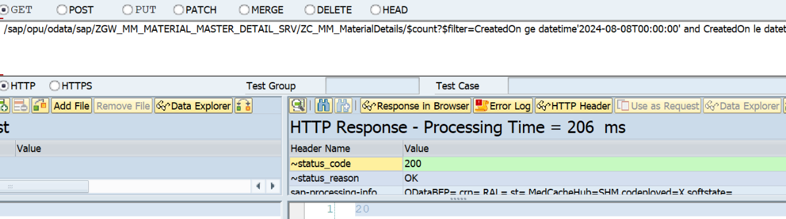

Postman level Check.  
http://mehdevpas.minda.com:8001/sap/opu/odata/sap/ZGW_MM_MATERIAL_MASTER_DETAIL_SRV/ZC_MM_MaterialDetails?$filter=CreatedOn ge datetime'2024-08-08T00:00:00' and CreatedOn le datetime'2025-08-19T00:00:00'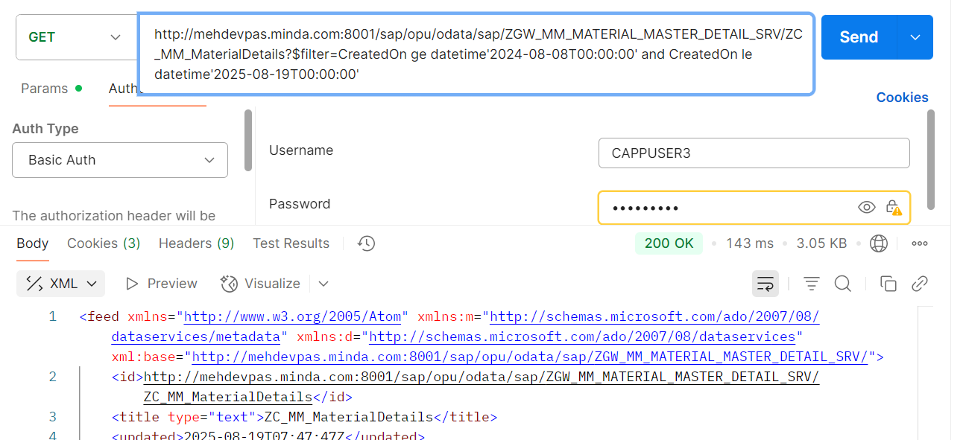

* ***LADAT (Last Changed ON):26-03-2025 to 19-08-2025***

API For Check the material data on the above date Criteria:

/sap/opu/odata/sap/ZGW_MM_MATERIAL_MASTER_DETAIL_SRV/ZC_MM_MaterialDetails?$filter=LastChangedOn ge datetime'2025-03-26T00:00:00' and LastChangedOn le datetime'2025-08-19T00:00:00'

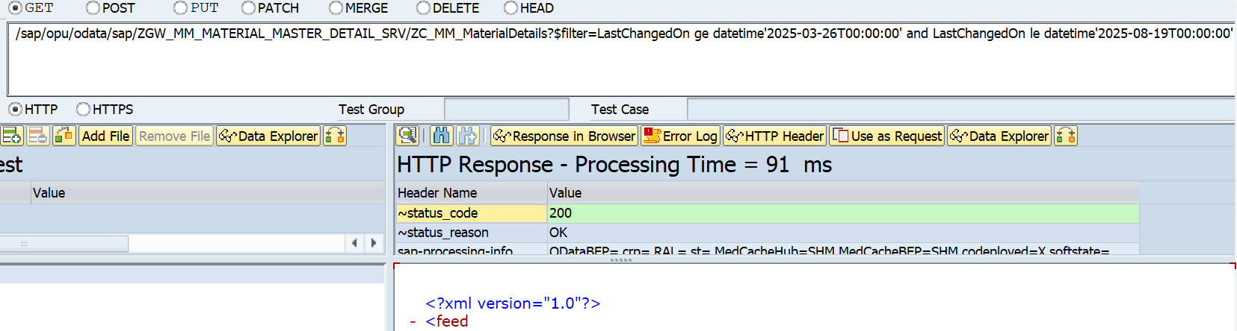

API for check the number of rows get from SAP.(For checking Purpose)  
/sap/opu/odata/sap/ZGW_MM_MATERIAL_MASTER_DETAIL_SRV/ZC_MM_MaterialDetails/$count?$filter=LastChangedOn ge datetime'2025-03-26T00:00:00' and LastChangedOn le datetime'2025-08-19T00:00:00'

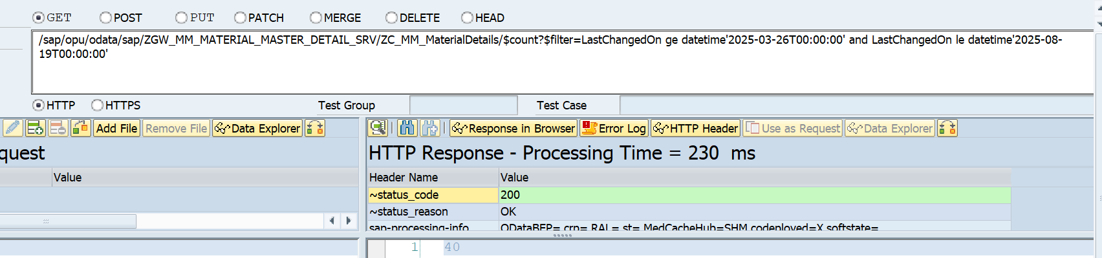

Postman level Check.

http://11.1.3.57:8001/sap/opu/odata/sap/ZGW_MM_MATERIAL_MASTER_DETAIL_SRV/ZC_MM_MaterialDetails?$filter=LastChangedOn ge datetime'2025-03-26T00:00:00' and LastChangedOn le datetime'2025-08-19T00:00:00'

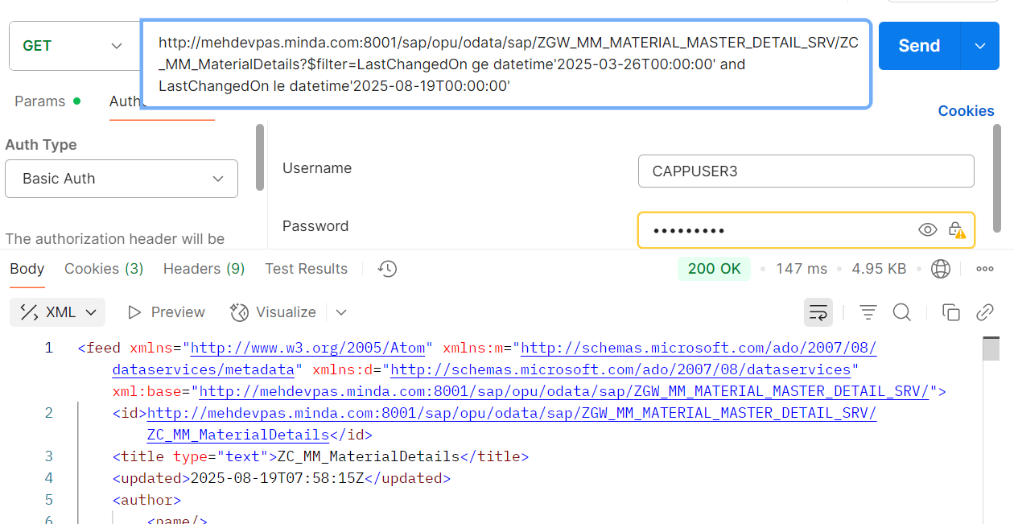

**Case 3: If user want to check the Existing Plant details of a Material.**

Material Code: RALAA1CHIF116Z

Navigation Property: to_MaterialPlant

SAP GUI Level/Gateway Client Level.  
API

/sap/opu/odata/sap/ZGW_MM_MATERIAL_MASTER_DETAIL_SRV/ZC_MM_MaterialDetails(MaterialCode='RALAA1CHIF116Z',Plant='3701')/to_MaterialPlant

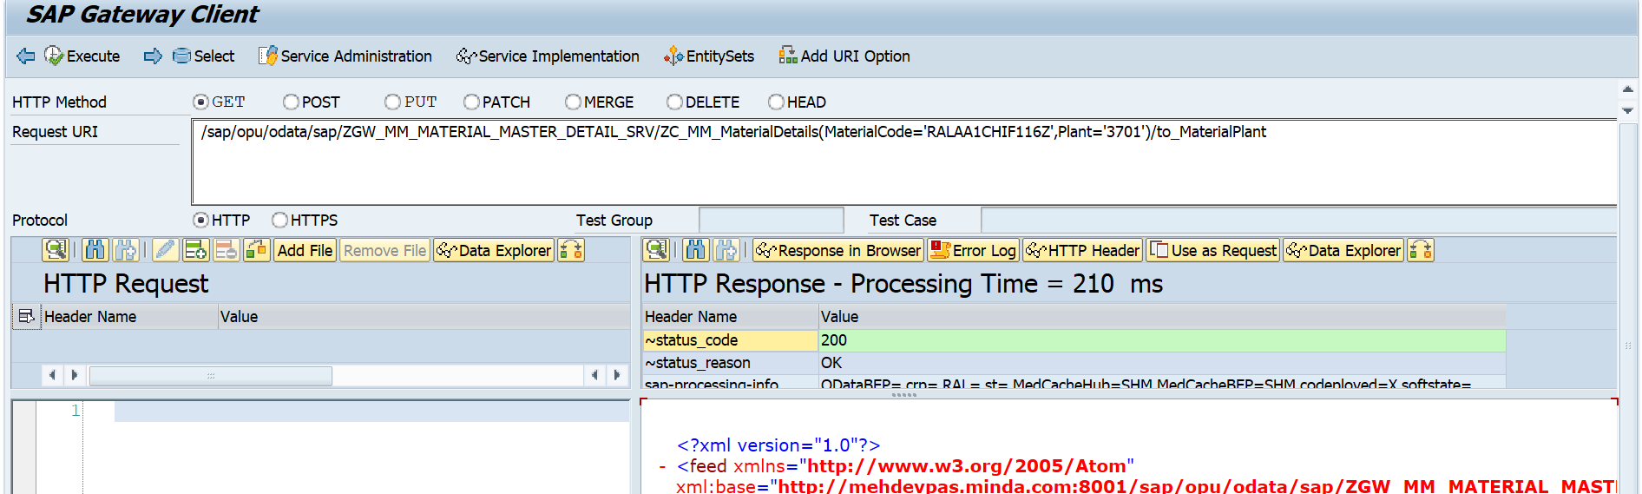

Note: by using the navigation property “to_MaterialPlant” we can access the Plant details of material.

API for check the Number of plant related to the Material for confirmation.

/sap/opu/odata/sap/ZGW_MM_MATERIAL_MASTER_DETAIL_SRV/ZC_MM_MaterialDetails(MaterialCode='RALAA1CHIF116Z',Plant='3701' )to_MaterialPlant/$count

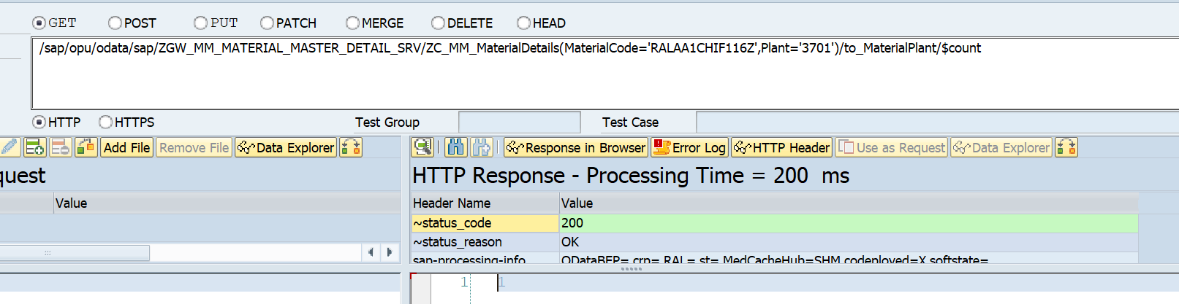

Postman Level

http://mehdevpas.minda.com:8001/sap/opu/odata/sap/ZGW_MM_MATERIAL_MASTER_DETAIL_SRV/ZC_MM_MaterialDetails(MaterialCode='RALAA1CHIF116Z',Plant='3001')/to_MaterialPlant

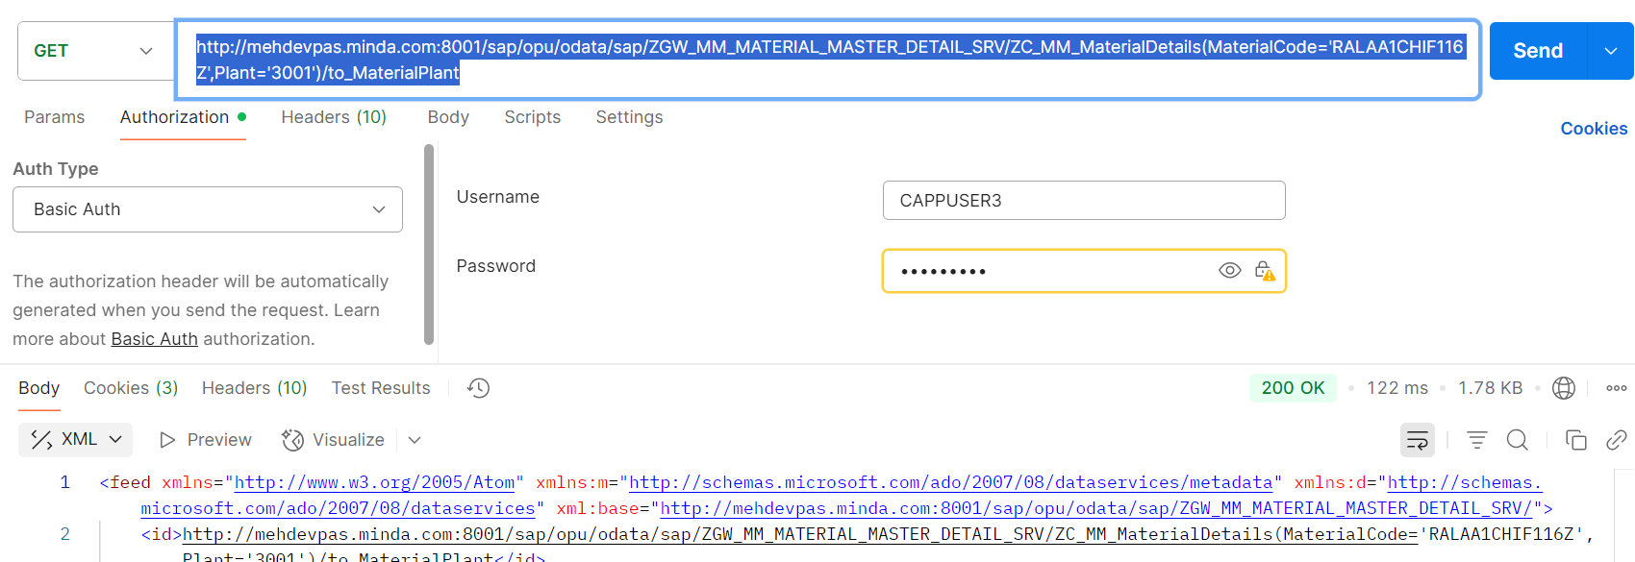

**Case 4: if user want to check the storage location details of the material.**

Material Code: RALAA1CHIF116Z

Navigation Property: to_MaterialStorageLoc

SAP GUI Level/Gateway Client Level.  
API

/sap/opu/odata/sap/ZGW_MM_MATERIAL_MASTER_DETAIL_SRV/ZC_MM_MaterialDetails(MaterialCode='RALAA1CHIF116Z',Plant='3001')/to_MaterialStorageLoc

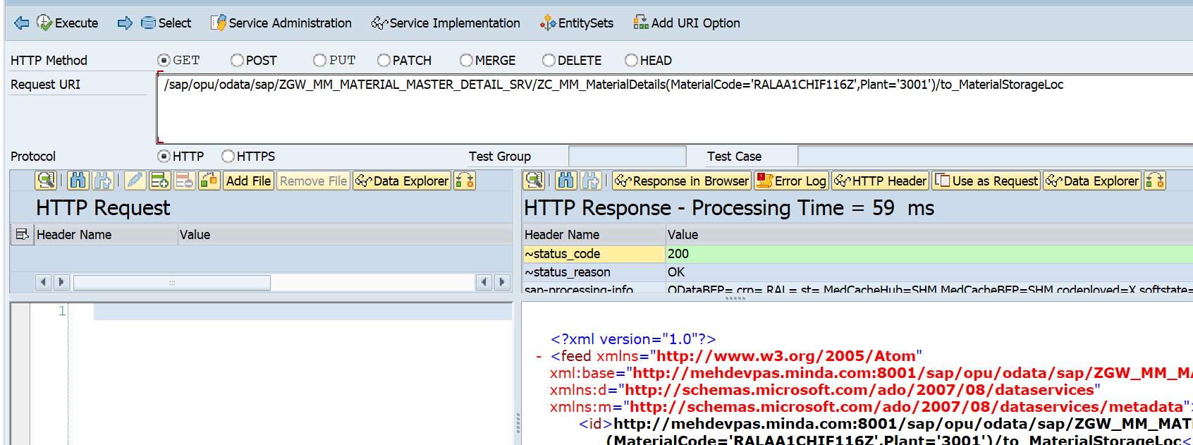

API for check the total number of Storage location Related to the material for check.  
/sap/opu/odata/sap/ZGW_MM_MATERIAL_MASTER_DETAIL_SRV/ZC_MM_MaterialDetails(MaterialCode='RALAA1CHIF116Z',Plant='3001')/to_MaterialStorageLoc

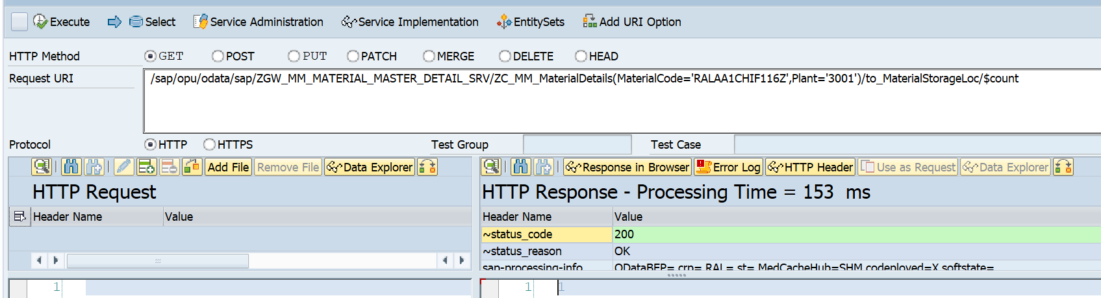

Postman Level Checking

[http://11.1.3.57:8001/sap/opu/odata/sap/ZGW_MM_MATERIAL_MASTER_DETAIL_SRV/ZC_MM_MaterialDetails(MaterialCode='RALAA1CHIF116Z',Plant='3001')/to_MaterialStorageLoc](http://11.1.3.57:8001/sap/opu/odata/sap/ZGW_MM_MATERIAL_MASTER_DETAIL_SRV/ZC_MM_MaterialDetails('RALAA1CHIF116Z')/to_MaterialStorageLoc)

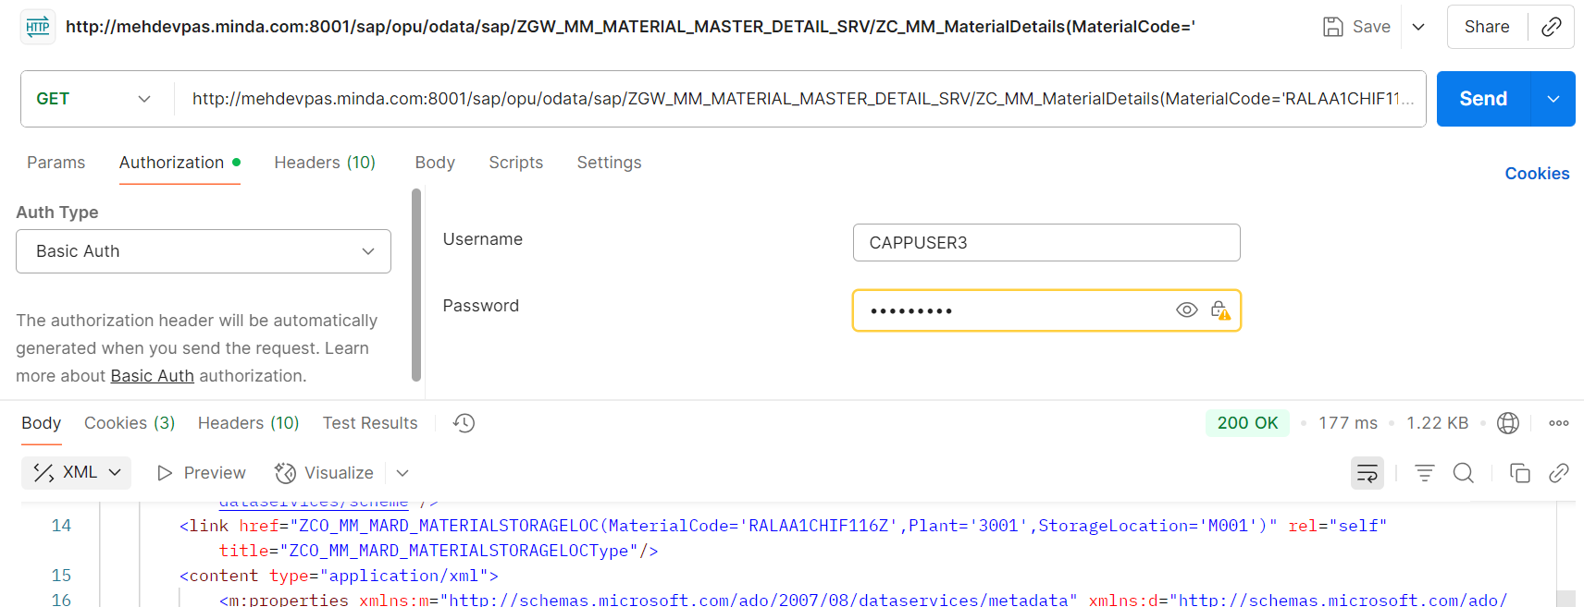

**Case 5: if user want to check the Material Valuation details of the material.**

Material Code: RALAA1CHIF116Z

Navigation Property: to_MaterialValuation

SAP GUI Level/Gateway Client Level.  
API

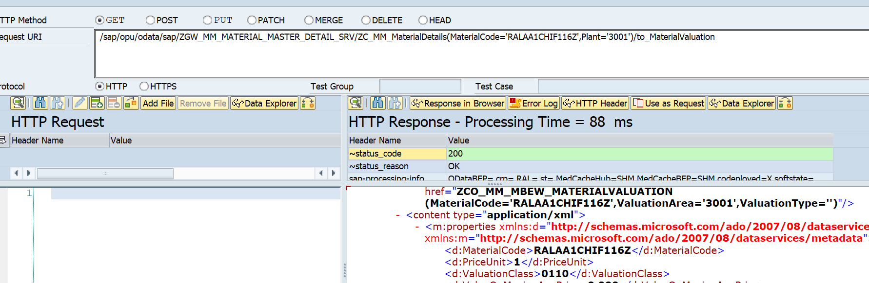/sap/opu/odata/sap/ZGW_MM_MATERIAL_MASTER_DETAIL_SRV/ZC_MM_MaterialDetails(MaterialCode='RALAA1CHIF116Z',Plant='3001')/to_MaterialValuation

for check the number of Valuation Details of material.  
/sap/opu/odata/sap/ZGW_MM_MATERIAL_MASTER_DETAIL_SRV/ZC_MM_MaterialDetails(MaterialCode='RALAA1CHIF116Z',Plant='3001')/to_MaterialValuation /$count

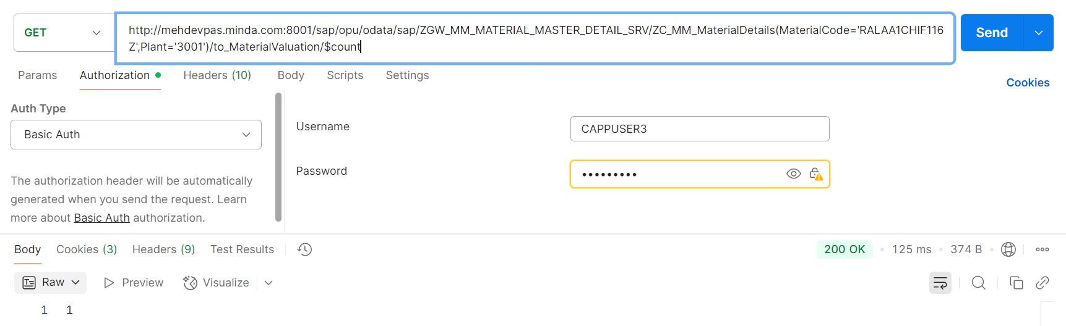

Postman Level Check.  
<http://11.1.3.57:8001/sap/opu/odata/sap/ZGW_MM_MATERIAL_MASTER_DETAIL_SRV/ZC_MM_MaterialDetails(MaterialCode='RALAA1CHIF116Z',Plant='3001')/to_MaterialValuation>

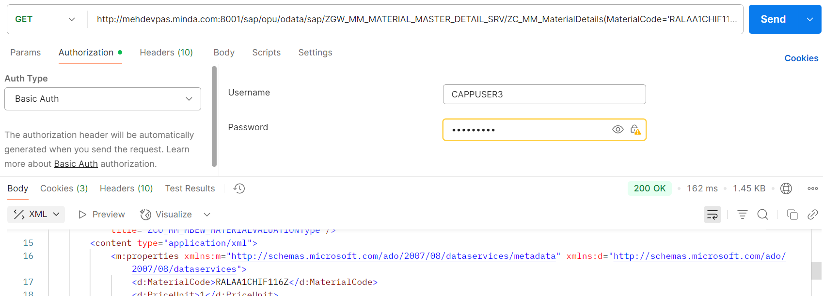

**Case 6: if user want to check the Material Sales Related details of the material.**

Material Code: RALAA1CHIF116Z

Navigation Property: to_MaterialAlternativeUOM

SAP GUI Level/Gateway Client Level.  
API

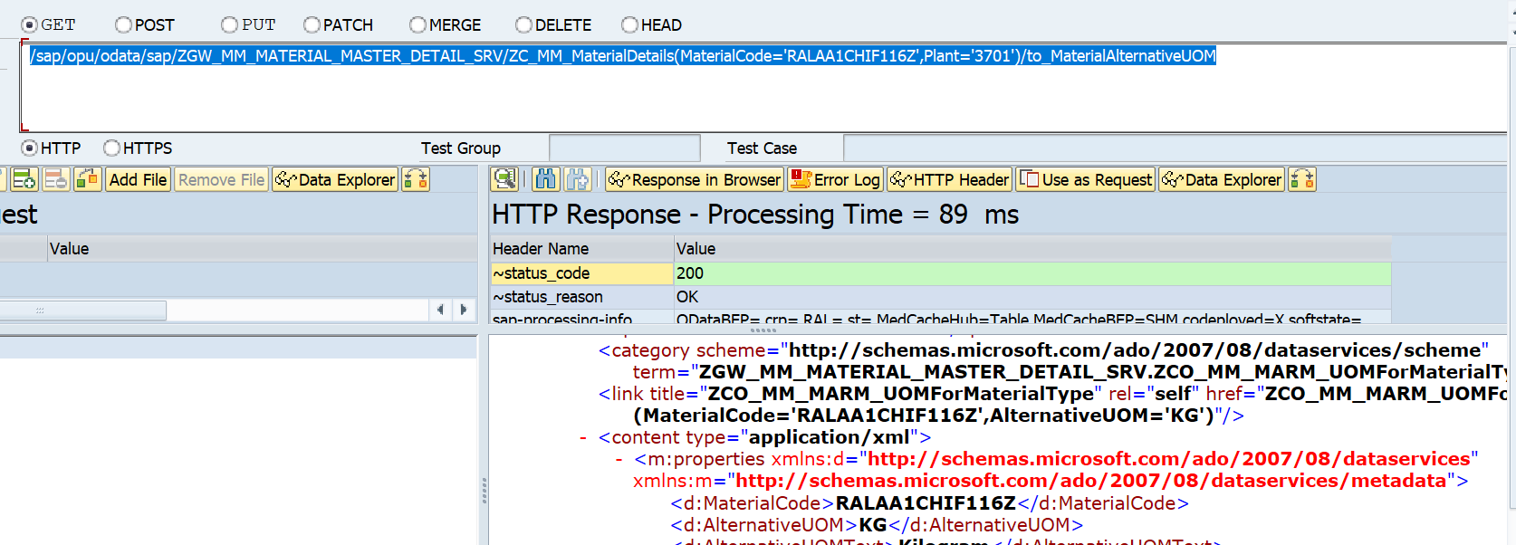/sap/opu/odata/sap/ZGW_MM_MATERIAL_MASTER_DETAIL_SRV/ZC_MM_MaterialDetails(MaterialCode='RALAA1CHIF116Z',Plant='3701')/to_MaterialAlternativeUOM

Postman Level Check

<http://11.1.3.57:8001/sap/opu/odata/sap/ZGW_MM_MATERIAL_MASTER_DETAIL_SRV/ZC_MM_MaterialDetails(MaterialCode='RALAA1CHIF116Z',Plant='3701')/to_MaterialAlternativeUOM>

**Case 7: if user want to check the Material Sales Related details of the material.**

Material Code: RALAA1CHIF116Z

Navigation Property: to_MaterialSales

SAP GUI Level/Gateway Client Level.  
API

/sap/opu/odata/sap/ZGW_MM_MATERIAL_MASTER_DETAIL_SRV/ZC_MM_MaterialDetails(MaterialCode='RALAA1CHIF116Z',Plant='3001')/to_MaterialSales  
  
Here there is no sales data available for this Material, so in the Response body no record is coming or the response Body is Blank but here the status will be 200, don’t confuse.

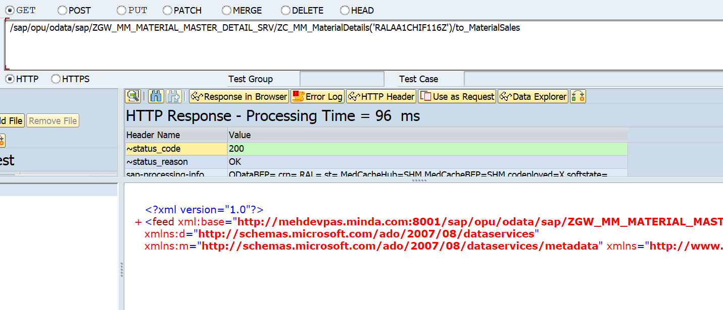

Postman Level Check

[http://11.1.3.57:8001/sap/opu/odata/sap/ZGW_MM_MATERIAL_MASTER_DETAIL_SRV/ZC_MM_MaterialDetails(MaterialCode='RALAA1CHIF116Z',Plant='3001')/to_MaterialSales](http://11.1.3.57:8001/sap/opu/odata/sap/ZGW_MM_MATERIAL_MASTER_DETAIL_SRV/ZC_MM_MaterialDetails('')/to_MaterialSales)

**Case 8: if user want to check the Material Tax Classification Related details of the material.**

Material Code: RALAA1CHIF116Z

Navigation Property: to_MaterialTaxClassification

API

/sap/opu/odata/sap/ZGW_MM_MATERIAL_MASTER_DETAIL_SRV/ZC_MM_MaterialDetails(MaterialCode='RALAA1CHIF116Z',Plant='3701')/to_MaterialTaxClassification

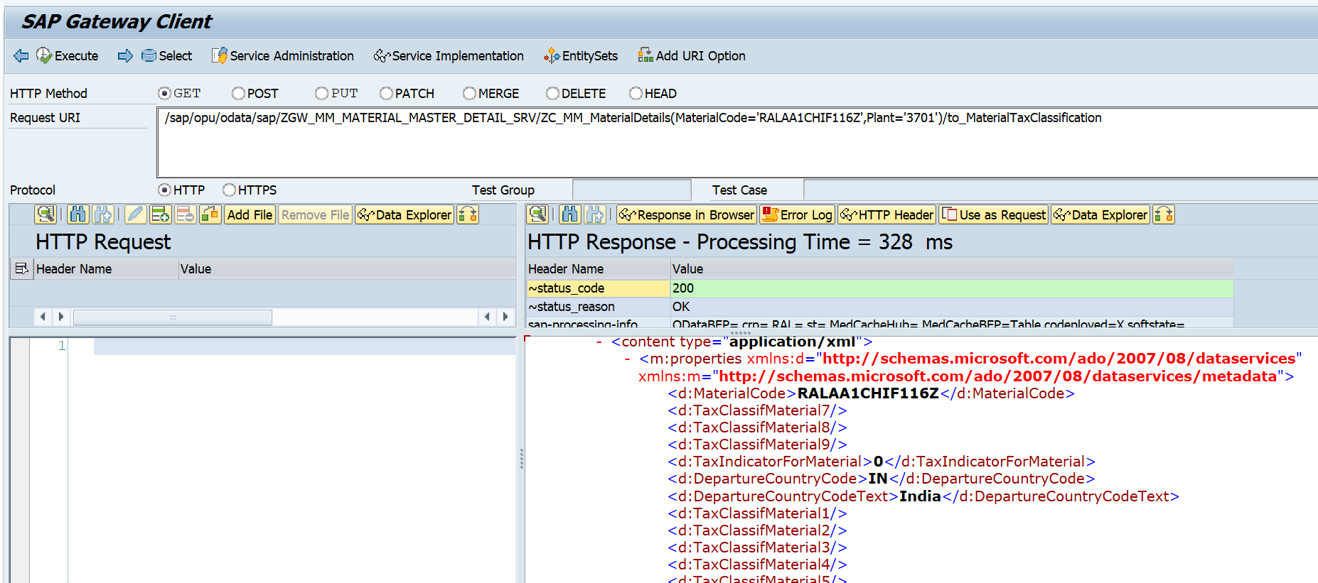

Postman Level

http://11.1.3.57:8001/sap/opu/odata/sap/ZGW_MM_MATERIAL_MASTER_DETAIL_SRV/ZC_MM_MaterialDetails(MaterialCode='RALAA1CHIF116Z',Plant='3001')/ to_MaterialTaxClassification